Final Year Project
QuickHired–AI Powered Job Interview Assistant



By

Mehroz Ahmad 2022-gcg-469
Syed Muhammad Ahsan 2022-gcg-83
Abdullah 2022-gcg-135
Abdul Raheem Nasir 2022-gcg-129
Under the supervision of
Prof.
Sir Kashif Riaz
Bachelor of Science in Information Technology
(2022-2026)
FACULTY OF COMPUTING & INFORMATION
TECHNOLOGY (FCIT),
UNIVERSITY OF THE PUNJAB, LAHORE

QuickHired–AI Powered Job Interview Assistant

A project presented to
University of the Punjab, Lahore
In partial fulfillment of the requirement for the
degree of
Bachelors of Science in Information Technology
(2022-2026)

By

Mehroz Ahmad 2022-gcg-469
Syed Muhammad Ahsan 2022-gcg-83
Abdullah 2022-gcg-135
Abdul Raheem Nasir 2022-gcg-129

FACULTY OF COMPUTING & INFORMATION
TECHNOLOGY (FCIT),
UNIVERSITY OF THE PUNJAB, LAHORE

DECLARATION
We hereby declare that this software, in whole or in part, has not been copied from any source. We further declare that we have developed this software and the accompanying report entirely on the basis of our own efforts. If any part of this project is found to be copied or reproduced from any source, we accept full responsibility for the consequences. We also declare that no portion of the work presented in this project has been submitted for any degree or qualification in this or any other university or institution of learning.

Signature:__________________ Signature:________________
Mehroz Ahmad 076414 Syed Muhammad Ahsan 076363

Signature:_________________ Signature:________________
Abdullah 076381 Abdul Raheem Nasir 076331

CERTIFICATE OF APPROVAL

This is to certify that the final year design project (FYDP) of BS-IT “Quick Hired – AI Powered Job Interview Assistant” was developed by Mehroz Ahmad (2022-gcg-469), Syed Muhammad Ahsan (2022-gcg-83), Abdullah (2022-gcg-135), Abdul Raheem Nasir (2022-gcg-129) under the supervision of “Prof. Kashif Riaz ”. In my opinion, the project is fully adequate in scope and quality and meets the requirements for the degree of Bachelors of Science in Information Technology.

Signature: ______________
FYDP Supervisor

Signatures (Faculty Advisory Committee FAC)
Signature
Name
 | FAC1 | FAC2 | FAC3 | FAC4 | FAC5

Executive Summary

QuickHired is an AI-driven web application designed to assist job seekers in preparing for real and mock interviews with confidence and efficiency. The platform offers a full digital interview experience where users can register, verify their email, and access features like AI Interview Copilot and AI Mock Practice. Using advanced AI algorithms, QuickHired generates realistic interview questions, evaluates user responses in real time, and provides detailed feedback including strengths, areas for improvement, confidence scores, and AI-generated summaries.
The system integrates secure user authentication using JWT tokens, ensures reliable communication through REST APIs, and employs SendGrid for email notifications. Users can also build professional resumes, generate tailored cover letters and follow-up emails, view performance reports with charts, and track progress over time. Subscription plans are handled via Stripe, offering both free and premium membership tiers.
Overall, QuickHired delivers an intelligent, interactive, and user-friendly platform to enhance interview readiness, helping users practice, perform, and improve their job interview skills effectively.

Acknowledgement
First and foremost, we would like to express our sincere gratitude to Prof. Kashif Riaz, our FYP supervisor, for his invaluable guidance, support, and encouragement throughout the development of this project. We would also like to thank our department and faculty members for providing the necessary resources and an academic environment that facilitated learning and innovation. Special thanks to our peers and friends who offered suggestions, motivation, and technical assistance whenever needed. Finally, we are grateful to our families for their continuous support and understanding, which enabled us to dedicate the time and effort required to complete this project successfully

Signature:__________________ Signature:________________
Mehroz Ahmad 076414 Syed Muhammad Ahsan 076363

Signature:_________________ Signature:________________
Abdullah 076381 Abdul Raheem Nasir 076331

Table of Contents
1. Introduction .....................................................................................................
1.1 Problem Statement ............................................................................................... 12
1.2 Problem Solution .................................................................................................. 13
1.3 Objectives of the Proposed System .......................................................................... 14
1.4 Scope .................................................................................................................. 15
1.5 System Components .............................................................................................. 16
1.6 Related System Analysis/Literature Review ............................................................. 18
1.7 Vision Statement .................................................................................................. 21
1.8 System Limitations and Constraints ........................................................................ 22
1.9 Tools and Technologies ......................................................................................... 24
1.10 Project Deliverables .............................................................................................. 25
1.11 Project Planning ................................................................................................... 28
1.12 Gantt Chart……………………………………………………………………………………………………….30
1.12 Summary ............................................................................................................. 30
2. Analysis .................................................................................................
2.1 User classes and characteristics .............................................................................. 32
2.2 Requirement Identifying Technique ........................................................................ 34
2.3 Functional Requirements ....................................................................................... 38
2.3.1 Functional Requirement X ..................................................................................... 43
2.4 Non-Functional Requirements ............................................................................... 43
2.4.1 Reliability ............................................................................................................ 43
2.4.2 Usability ......................................................................................................... 44
2.4.2 Performance ................................................................................................... 45
2.4.3 Security ........................................................................................................... 47
2.5 External Interface Requirements ......................................................................... 47
2.5.1 User Interfaces Requirements ........................................................................... 47
2.5.2 Software interfaces ........................................................................................... 50
2.5.3 Hardware interfaces .......................................................................................... 52
2.5.4 Communications interfaces ................................................................................ 52
2.6 Summary ............................................................................................................. 53
3. System Design .......................................................................................
3.1 Design considerations ............................................................................................ 59
3.2 Design Models ...................................................................................................... 60
3.3 Architectural Design ............................................................................................. 63
3.4 Design Decisions ................................................................................................... 65
3.5 Summary ............................................................................................................. 67
4. Implementation .................................................................................
4.1 Algorithm ............................................................................................................ 69
4.2 External APIs/SDKs ............................................................................................. 72
4.3 Code Repository ................................................................................................... 74
4.4 Summary ............................................................................................................. 75
5. Introduction .......................................................................................
5.1 Unit Testing (UT) ................................................................................................. 77
5.2 Functional Testing (FT) ......................................................................................... 78
5.3 Integration Testing (IT) ......................................................................................... 78
5.4 Performance Testing (PT) ...................................................................................... 79
5.5 Summary ............................................................................................................. 80
6. Introduction .........................................................................................
6.1 Conversion Method .............................................................................................. 82
6.2 Deployment .......................................................................................................... 84
6.3 Post Deployment Testing ....................................................................................... 88
6.4 Challenges ........................................................................................................... 91
6.5 Summary ............................................................................................................. 94
7. Introduction ..........................................................................................
7.1 Evaluation ........................................................................................................... 96
7.2 Traceability Matrix ............................................................................................... 97
7.3 Conclusion ........................................................................................................... 98
7.4 Future Work ........................................................................................................ 98

Chapter 1
Introduction


Chapter No.1

Introduction
This chapter provides a comprehensive overview of the proposed project, outlining its fundamental purpose, significance, and expected contributions. It introduces the problem domain, describes the motivation behind the system, and establishes the foundation for understanding the project’s overall direction. By presenting clear objectives, defined scope, and the analysis of related systems, this chapter sets the context for the entire project. It guides the reader in understanding how the proposed solution addresses existing challenges and ensures alignment with the broader goals of the system. Ultimately, this chapter serves as a roadmap that connects the project vision with the detailed technical development covered in the subsequent chapters.

Problem Statement:
- In today’s world, many students and job seekers feel nervous and unprepared during job interviews. They don’t know what questions will be asked, how to answer professionally, or how to improve their communication skills. Because of this, they fail interviews even when they have good knowledge.

- There is no easy tool that gives personalized practice, instant feedback, or AI-based guidance to help users identify their weaknesses and improve their interview performance. Most people depend on random YouTube videos or generic tips, which do not match their specific job role or skill level. As a result, users do not get the proper training they need to feel confident in real interviews.

- Our project Quick Hired – AI Powered Job Interview Assistant aims to solve this problem by providing an intelligent platform where users can practice real interview situations. The system generates job-related questions, analyzes user answers, gives feedback, and helps users improve step by step. This will help job seekers become more confident, prepared, and successful in their interviews.

Question No.1:
Why are you developing this software system?
Answer:
We are developing the Quick Hired – AI Powered Job Interview Assistant because many job seekers do not get proper interview preparation. Most students and fresh graduates feel confused and scared before interviews.

They do not know how to answer questions confidently or professionally. Many people do not have mentors or experts to guide them. Traditional preparation methods do not give personalized, real-time support. YouTube videos and notes cannot tell users their mistakes.

There is no easy tool that provides real interview practice at home. Many candidates fail because they cannot communicate clearly, even if they have good skills. Companies expect smart, confident, and structured answers from applicants. Our system acts like a virtual interview coach for every user. It reduces stress and builds confidence through continuous practice. The system also offers a special feature where users can give their real interview through screen sharing. During the screen-shared interview, AI quietly provides helpful suggestions and answer guidance in the background. This allows users to perform better in the actual interview without feeling lost or stuck. With this support, even first-time job seekers can perform like trained candidates. This is why we are building a powerful system that guides users from zero to professional level in interview preparation.

Question No.2:
What problem your software system is going to solve?
Answer:
Our system solves the problem of poor and incomplete interview preparation among job seekers.
Most candidates do not know what interview questions will be asked. They also do not know the correct and professional way to answer them. Users cannot identify their weak points without proper guidance.
Most other available tools only give general tips and do not provide personalized support.

People practice randomly and do not know if they are improving. There is no platform that uses AI to give smart, role-based interview practice. Our system generates questions based on job roles, skills, and experience level. It listens to the user’s answers and gives instant feedback on tone, clarity, and structure. The system also provides guidance for improving communication and confidence.

It helps users understand exactly where they made mistakes. At the end of the practice session, the system creates a detailed interview summary. It also generates a complete AI-based report showing strengths, weaknesses, and improvement tips. This summary and report can also be sent to the user’s email for easy saving and review. Users can track their performance over time using these reports.

In short, our system solves the problem of unprepared candidates by giving them a complete AI-powered interview practice, feedback, reporting, and email.

1.2 Problem Solution:
The solution to the problem is to create an AI-powered interview preparation system that helps users practice and improve their interview skills. The software provides job-specific interview questions based on the user’s selected job role or skills. It listens to the user’s answers and gives real-time feedback for improving clarity, tone, and confidence. The system also guides users step-by-step on how to structure professional answers. It creates a virtual interview environment so users can practice anytime without a human trainer.

The application gives personalized feedback that matches the user’s performance level. At the end of every session, the system generates a complete interview summary.

It also prepares an AI-based report showing strengths, weaknesses, and suggestions for improvement.
This report helps users understand exactly where they need more practice. The summary and report can also be sent to the user’s email for record keeping. The system helps reduce interview stress by showing users how to answer confidently. It supports different job categories so every type of job seeker can practice. The application also improves communication skills by highlighting mistakes and giving better sentence suggestions.

Users can track their progress over time using their saved reports and summaries. The goal of this software is to prepare job seekers so they can perform strongly in real interviews.
Overall, the solution ensures that users become confident, prepared, and ready for successful job interviews.

1.3 Objectives of the Proposed System

The primary objective of the proposed system, QuickHired, is to develop an intelligent and user-friendly platform that assists job seekers throughout their interview and job application journey using advanced AI technologies. The system is designed to enhance interview readiness, improve the quality of application documents, and streamline the overall job-seeking process.

The specific objectives of the proposed system are:

- To provide AI-powered interview preparation tools

- Generate personalized interview questions based on the user's job role, skills, and experience.

- Conduct mock interviews with real-time AI feedback to help users improve their confidence and communication skills.

- To automate the creation of professional job application documents

- Produce recruiter outreach and follow-up emails in a professional tone.

- To offer personalized career insights and recommendations

- Provide performance analysis after mock interviews.

- Suggest improvements in communication, responses, and overall interview approach.

- To implement a secure and efficient subscription model

- Integrate Stripe for monthly and annual subscription payments.

- Ensure secure handling of user payment data and authentication.

- To ensure a seamless user experience through modern web technologies

- Develop a responsive and intuitive frontend using Angular.

- Build a robust and scalable backend using ASP.NET Core.

- Enable smooth interaction between the user interface, AI engine, and database.

- To maintain a secure environment for user data

- Implement secure authentication and authorization mechanisms.

- Protect user profile information, generated documents, and payment details.

1.4 Scope:
Scope of Quick Hired – AI-Powered Job Interview Assistant
1. Clear and Specific:
The system is designed to help job seekers prepare for interviews, create resumes, cover letters, and professional emails, and manage their job applications in one platform.
It focuses on AI-powered guidance and feedback rather than general career advice.

2. Deliverables are Defined:
- AI-powered interview question generator and mock interview module.
- Resume and cover letter builder.
- AI-generated recruiter and follow-up emails.
- Secure login and user authentication.
- Stripe-based subscription payment system.

3. System Boundaries / Delimitations:
- The system only supports English for document generation and communication.
- It does not provide direct job placement or recruitment services.
- AI feedback is limited to user input in mock interviews and documents.
- The platform will not handle offline interviews or in-person coaching.

4. Identify Stakeholders:
- Primary Users: Job seekers (students, fresh graduates, professionals)
- Administrators: System managers who handle user subscriptions and content updates
- Developers: Responsible for system maintenance and upgrades
- Third-party Services: Stripe (for payment processing)

5. Must Align with Objectives:
All system features directly support the objectives: AI interview preparation, professional document generation, real-time feedback, and streamlined job application management.

6. Set Priorities / Key Features:
Key features are as follows:
- High priority:
- AI-based interview preparation.
- Resume and cover letter builder.
- Medium priority:
- AI-generated emails.
- Subscription management.
- Low priority:
- UI personalization or additional analytics reports.

7. Constraints:
- Time: Project development must be completed within the academic timeline.

- Technology: System will use Angular (frontend) and ASP.NET Core (backend) only.

- Resources: Limited to available computing resources and cloud services for AI integration.

8. Milestones:

Week 1–2: Requirement analysis and system design

Week 3–5: Frontend and backend development

Week 6–7: AI integration for interviews and documents

Week 8: Payment system and authentication setup

Week 9: Testing and bug fixing

Week 10: Final deployment and documentation submission

1.5 System Components:

The proposed system consists of several key modules/components. Each module is designed to make the application efficient, user-friendly, and powerful for interview and meeting preparation.

1. Frontend (Angular)

- User Interface Module: Clean and intuitive interface, easy navigation across all features.

- User Authentication Module: Secure login, signup, and password recovery.

- Interview Practice Module: Job-specific questions, answer recording, real-time AI feedback.

- Live Screen Share & Meeting Module: Users can record their meetings if they are busy.

- Application generates summary, transcription, and reports from the recording.
- Users can share live meeting screens and the AI listens silently, generating end-of-meeting summaries and transcriptions.

- Report & Summary Module: Shows detailed interview and meeting reports, downloadable and sendable via email.

- Subscription & Payment Module:

- Free account has limits on mock interviews, tools, resume builder, and other features.
- Paid plans include Standard (monthly & yearly) and Pro (monthly & yearly) with full feature access.
- Users cannot access restricted features without upgrading their plan.

2. Backend (ASP.NET Core)

- Question & Meeting Management Module: Stores and sends job-specific questions, manages recorded and live meetings.

- AI Feedback Module: Provides real-time feedback on answers, generates transcription, summary, and improvement suggestions.

- Report Generation Module: Creates detailed reports for interviews and meetings, highlighting strengths, weaknesses, and actions.

- Email Module: Sends interview and meeting summaries/reports to user email.

- User Profile & Progress Module: Tracks history, progress, and subscription status securely.

3. Database Module

- Data Storage Module: Efficient storage for users, questions, answers, meeting recordings, reports, and transcripts.

4. Admin Panel (Angular + ASP.NET Core)
- Admin Management Module: Manages questions, categories, user activity, meetings, and subscription plans.

Key Features:

- Clean and simple interface with easy navigation.

- Shows all main features: practice interviews, live screen share, meetings, reports, and profile.

- Displays job-specific interview questions clearly.

- Allows users to record or type answers.

- Provides real-time AI feedback for answers.

- Generates summary and AI reports for each interview session.

- Allows download or email of reports.

- Fully responsive for mobile, tablet, and desktop.

- Provides record meeting feature for users who are busy.

- Generates summary, transcription, and report for recorded meetings.

- Supports live meeting screen share, AI listens silently and provides end-of-meeting summary.

- Interactive buttons and menus for smooth experience.

- Notifications and reminders for sessions, emails, or subscription updates.

- Tracks progress visually with charts and indicators.

- Integrates seamlessly with all other frontend modules.

- Handles subscription/payment info and restricts free account features until plan upgrade.

1.6 Related System Analysis / Literature Review

This section reviews existing platforms, tools, and research relevant to interview preparation, AI-powered career assistance, and job application automation. The purpose of this analysis is to identify the strengths and limitations of current systems and to justify the need for a more comprehensive and intelligent solution like QuickHired.

1.Existing Interview Preparation Platforms

1. Glassdoor Interview Questions

Glassdoor provides user-submitted interview questions and company reviews. While it helps users understand common questions asked by specific companies, it lacks:

- Personalized question generation

- Real-time feedback

- Mock interview simulation

- Document creation tools

- Limitation: Static data, not personalized for each user.

2. LeetCode / HackerRank (Interview Practice)

These platforms focus mainly on coding interviews, providing problem-solving exercises and coding challenges. They are useful for technical skills but:

- Offer no soft-skills or HR interview practice

- Do not provide resume, cover letter, or email generation

- Do not give personalized communication feedback

- Limitation: Limited to programming interviews only.

3. InterviewBuddy / HireVue

- These platforms offer video-based mock interviews using automated evaluation. However:

- Features are restricted and often expensive

- Feedback is generic, not deeply personalized

- No integrated resume builder or job application tools

- Limitation: Focus only on interviews, not the whole application process.

2. Existing AI Document Generators

1. Resume.io / Canva Resume Builder

- These tools provide templates and AI-based suggestions. However:

- They do not integrate mock interviews

- No follow-up or recruiter email generation

- No subscription-based personalized career insights

- Limited customization for job roles

- Limitation: Only assist with documents, not interview training.

2. ChatGPT-based Resume/Email Generation

- While AI chat tools can generate resumes, cover letters, and emails:

- They lack a structured job preparation workflow

- No user profiles or saved applications

- No payment system for premium features

- No dedicated platform for interview analysis

- Limitation: Not an integrated system; requires manual effort.

3. Payment-Integrated Job Tools

- Some platforms offer premium access through payment gateways but:

- Provide only document tools or only interview tools

- Do not combine all features into one system

- Do not use Stripe or modern subscription models

- Limitation: Fragmented solutions requiring users to visit multiple sites.

4. Gaps in Existing Systems

- From the above analysis, the key gaps in current solutions are:

- Lack of a single unified platform that covers interview preparation + resumes + emails + mock interviews.

- Limited personalization in existing AI systems.

- No comprehensive dashboard for users to track their interview readiness.

- No real-time AI feedback during mock interviews.

- No secure and modern subscription model for advanced features.

5. Contribution of the Proposed System (QuickHired)

- QuickHired fills these gaps by providing:

- A fully AI-powered interview preparation system

- AI-generated resumes, cover letters, recruiter emails, and follow-up messages

- Stripe payment integration for monthly and yearly plans

- A combined Angular + ASP.NET Core architecture for performance and scalability

- Real-time feedback, personalized insights, and a dedicated user dashboard

1.7 Vision Statement:

For job seekers, students, and professionals. Who struggle to find a reliable, smart, and personalized way to practice interviews, improve confidence, and manage their meeting workflows effectively.

The Quick Hired – AI Interview Power Assistant
Is an AI-driven interview preparation and meeting support platform designed to help users enhance their communication, problem-solving, and presentation skills through interactive practice sessions.

That offers job-specific interview questions, automatic feedback on answers, real-time suggestions, meeting recording, AI-generated summaries, transcriptions, performance reports, and continuous skill improvement guidance, all inside one easy-to-use application

Unlike traditional coaching centers, manual interview practice methods, or simple mobile apps that only provide basic questions
Our product delivers an intelligent, all-in-one ecosystem powered by AI that listens, analyzes, guides, and supports the user throughout their entire interview journey—helping them prepare faster, learn smarter, and gain confidence to successfully secure jobs in a competitive market.

1.8 System Limitations and Constraints

The proposed system, Quick Hired – AI Interview Power Assistant, provides powerful AI-based interview practice and meeting support. However, like any software product, it has certain limitations (external factors we cannot control) and constraints (internal boundaries defined by the project team).

A. Limitations (External Factors Beyond Control)

- Internet Dependency
The system requires a stable internet connection for AI processing, meeting recording, and live feedback. Users with slow or unstable internet may face delays or reduced accuracy.

- AI Accuracy Dependence on Data
The quality of feedback depends on the training data and AI model capabilities. If the user speaks in noisy environments, heavy accents, or unclear audio, the AI may not fully understand the response.

- Device Performance
Older or low-spec devices may struggle with real-time recording, processing, and screen-sharing features, affecting system speed.

- Third-Party Service Limitations
The system may rely on external API services for speech-to-text, video processing, or AI analysis. Any downtime or limitations from these services can impact system performance.

- User Privacy Concerns
Some users may feel uncomfortable sharing voice recordings or meeting sessions, which can limit the effectiveness of the AI analysis.

- Browser Compatibility Issues
Features like screen-sharing or audio recording may behave differently across certain browsers or operating systems, especially older versions.

B. Constraints (Self-Imposed Internal Boundaries)

- Defined Project Scope
The system currently focuses on interview practice, meeting assistance, and performance reports. It does not include resume building, job search tools, or career counseling to maintain a clear and focused scope.

Limited Language Support
In the initial version, the system may primarily support English and simple Roman Urdu. Full multilingual support might be planned for future stages.

- User Interface Simplicity
To keep the platform easy for beginners, the design avoids overly complex dashboards or advanced technical controls. Simplicity is a chosen constraint.

- Storage and Data Retention
The system may restrict how long recordings, transcripts, and reports are stored to save cloud/storage costs and protect user privacy. Users might need to download files if they want long-term storage.

- Feature Prioritization
Only core features like AI feedback, transcription, meeting support, and summaries are included. Extra features such as advanced analytics, personality scoring, or multi-user mock interviews are planned for later phases.

- Security Measures Within Budget
The system follows standard security practices, but advanced enterprise-level security models (like SOC2, ISO-based audits, etc.) are outside the initial version’s constraints.

1.9 Technologies Section

Angular
Framework for building responsive, single-page web applications. Provides powerful data binding, modular architecture, and reusable components.

ASP.NET Core
Cross-platform framework for building scalable backend APIs and web apps with high performance. Supports dependency injection, middleware, and robust security features.

SQL Server
Relational database system for storing and managing structured data with support for advanced querying, indexing, and transactions.

OpenAI API
AI-powered API for natural language processing, code generation, and intelligent automation. Enables integration of GPT models into applications.

Stripe API
Payment processing platform for handling online transactions, subscriptions, and secure payments with developer-friendly SDKs.

JWT
Standard for securely transmitting information between parties as a JSON object. Used for authentication and authorization in web apps.

Serilog
Logging library for structured and queryable logs in .NET applications. Integrates easily with multiple sinks like files, databases, and cloud platforms.

AutoMapper
Object-to-object mapping library for .NET, simplifying the transformation of data between DTOs and domain models.

1.10 Project Deliverables:

The following deliverables will be produced during the development of the Quick Hired – AI Interview Power Assistant project. All these items are based on what a BS IT student can normally create in a Final Year Project.

A. Documents That I Can Make

- Project Planning Document
A simple document where I explain my idea, why I selected this project, what features I will make, and how I will complete the work step by step.

- Software Requirements Specification (SRS)
A document written in easy language that includes functional requirements, non-functional requirements, basic system description, limitations, and user needs.

- System Design (Simple Diagrams)
I will create basic diagrams such as:

    - Use Case Diagram

    - Context Level Diagram

    - Data Flow Diagram

    - Simple ER Diagram for database
These diagrams will help show how the system works.

B. Design / Screens That I Can Make

- Simple Wireframes
Rough sketches of the main screens like login page, interview practice screen, meeting recording screen, and results page.

- UI Prototype (Basic Frontend Design)
Using Figma or simple tools, I will make clean UI screens showing how the user will use the system.

C. Development Work That I Can Make

- Frontend (Angular)
- I will create frontend pages such as:

- Login & Signup

- Dashboard

- Interview Question Screen

- Recording / Feedback Screen

- Summary / Report Screen

Basic Backend (Node.js or Firebase or API)
I will connect the frontend with backend to save user data, store interview results, and manage user accounts.

AI Function (Simple Integration)
Instead of building a full AI from scratch, I will use an available API or library for:

- Speech-to-text

- Generating small summaries

- Giving basic feedback on answers
(Student level AI integration)

Database (Simple & Clean)
I will create tables for:

- Users

- Interview Attempts

- Summaries

- Meeting Records

D. Testing That I Can Do

Basic Test Cases
- I will write simple test cases like:

- Login working or not

- Recording saving or not

- Summary generating or not

- Data storing or not

Final Testing Report
A short document showing which features work properly and what improvements were made.

E. Final Items I Can Easily Create

- Working Web Application (Student-Level)
A simple but working version of Quick Hired where the user can:

- Practice interview questions

- Record answers

- Get basic feedback

- See summaries

- Final FYP Report
A complete report including all chapters, screenshots, diagrams, and explanations.

- User Guide
A short guide telling users how to use the system step by step.

- Final Presentation Slides
Slides for presenting the idea, features, screenshots, demo, and results.

1.11 Project Planning:

The project Quick Hired – AI Powered Job Interview Assistant has been planned carefully to complete all tasks step by step within the FYP timeline. A Gantt Chart is used to show the schedule of activities, milestones, and resources needed for each task.

1.Project Tasks and Planning 2.Requirement Gathering

Task Description: Collect all requirements for the system, including interview practice, AI feedback, recording, and summaries.

- Duration: 1 week

- Resources: Student researcher, supervisor guidance

- System Design

Task Description: Create basic system diagrams like use case, data flow, and ER diagrams. Also, plan the database and frontend structure.

- Duration: 1 week

- Resources: Student

- Frontend Development

Task Description: Develop main screens using Angular, including login, dashboard, interview module, recording, and summary pages.

- Duration: 2 weeks

- Resources: Student, PC, Angular framework

- Backend Development (C#)

Task Description: Create server-side code using C# for handling user accounts, storing interviews, generating summaries, and connecting frontend with the database.

- Duration: 2 weeks

- Resources: Student, PC, Visual Studio, SQL Server

- AI Integration

Task Description: Integrate AI for speech-to-text, basic feedback, and summaries using available APIs or libraries.

- Duration: 2 weeks

- Resources: Student, AI API, PC

- Testing

Task Description: Test each feature including login, interview practice, recording, summary generation, and data storage. Document test results.

- Duration: 1 week

- Resources: Student, supervisor guidance

- Milestones

- Completion of Requirement Gathering

- Approval of System Design

- Frontend Development Completed

- Backend & Database Completed

- AI Integration Completed

- Testing Completed

1.12 Gantt Chart
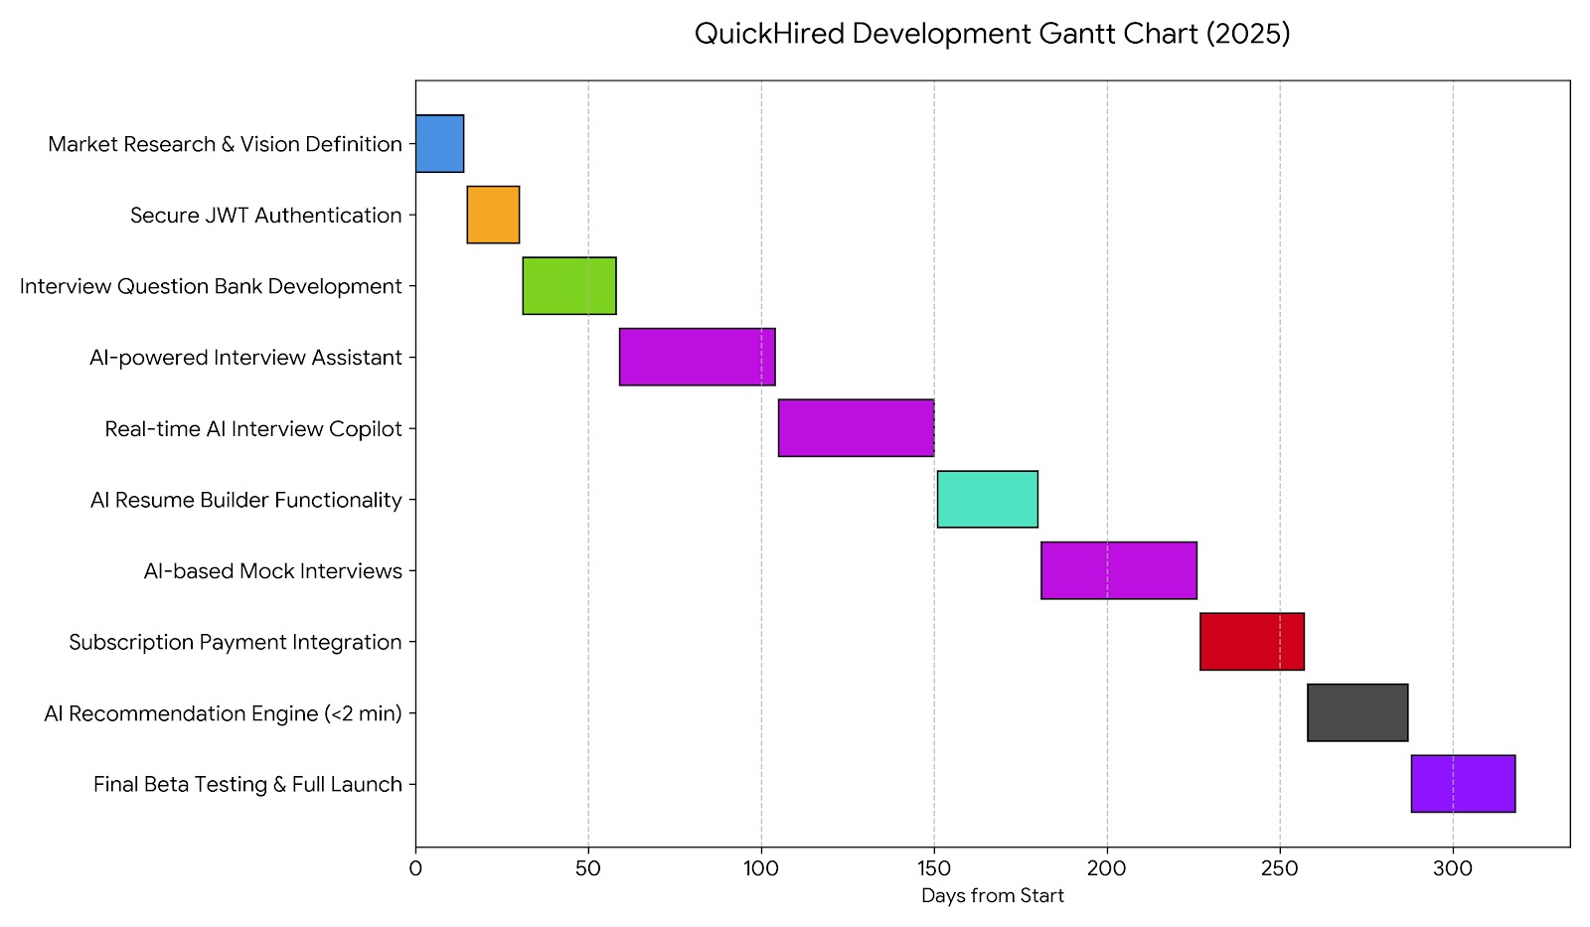

1.13 Overview
This chapter provides an overview of the proposed system, highlighting the problem, its solution, and the objectives of the project. It defines the system’s scope, components, and modules, clarifying the functionality and structure. A review of related systems establishes the relevance and novelty of the project, while the vision statement outlines its long-term impact. The chapter also discusses system limitations, tools, and technologies, justifying their selection for efficient and scalable development. Project deliverables and planning provide a clear roadmap for implementation. Overall, this chapter lays the foundation for the project, connecting the problem, objectives, and proposed solution to achieve the intended outcomes.

Chapter 2
Analysis

Chapter 2:

Requirements Analysis

2.1 User classes and characteristics:
The User Classes and Characteristics are as follows:
New User (Guest):
- Visits the website for the first time.
- Does not have an account yet.
- Can only see public pages like Home, About, Features.
- Needs easy Sign-Up and Login options.
- May use Google or Facebook login for quick access.
Registered User (Free Plan User):
- Has a registered account but limited access.
- Can try some features but only within free limits.
- Can create few interviews, mock sessions, or CVs.
- Sees pop-ups when the free limit is finished.
- May upgrade to paid plans.
Premium User (Standard Plan):
- Has upgraded to the Standard paid plan.
- Gets more features than the free plan.
- Can use Interview Copilot, AI Mock, and Resume Builder with extended limits.
- Gets better usage limits per month.
- Needs stable performance and smooth experience.
Premium User (Pro Plan):
- Highest-level paid user.
- Gets full access to all features.
- Maximum usage time for interviews and mock sessions.
- Can create unlimited CVs, cover letters, and AI tools.
- Priority email reports and faster processing.
Interviewee (Actual User Giving Interview):
- Uses AI Interview Copilot to give a real-time interview.
- Shares screen and allows app to capture questions.
- Relies on real-time AI-generated answers.
- Needs accuracy, speed, and privacy.
Mock Interview User (Practice User):
- Uses AI Mock feature for practice.
- Receives random or role-based questions.
- Gives answers manually to improve skills.
- Checks confidence score and weaknesses.
- Needs easy navigation and quick feedback.
Resume Builder User:
- Creates or edits AI-powered CVs.
- Enters personal details into templates.
- Uses “Enhance with AI” for better skills/content.
- Needs live preview and editable formats.
AI Tools User:
- Uses AI to generate Cover Letters, Thank You Emails, Follow-Up Emails, Recruiter Emails.
- Only inputs details; AI generates full content.
- Needs accuracy in writing and easy editing.
Super Admin
- Creates and manages the entire application structure (features, modules, backend setup).
- Monitors user activities, including login trends, interview usage, resume builder usage, and plan upgrades.
- Analyzes system records, such as performance logs, user growth stats, and AI tool usage reports.
- Manages all members, including viewing active users, blocked users, and subscription details.
- Monitors system health, including server status, database performance, and background jobs.
- Uses Serilog or other logging tools to track system errors, warnings, and important events.
- Requires the highest security level, with restricted access only for system owners or developers.

2.2 Requirement Identifying Technique:

To understand what the QuickHired application should do, different requirement-identifying techniques are used. These techniques help collect, analyze, and define the functional requirements clearly. The selection of each technique depends on the nature of the project.
QuickHired is an interactive end-user application that includes multiple features such as AI Interview Copilot, AI Mock Interviews, Question Bank, AI Resume Builder, AI Email Tools, and Payment Plans. Because this project involves step-by-step user interaction, multiple screens, forms, real-time features, and AI behaviour, the following techniques are chosen:

1. Use Case Technique
- Use Case analysis is the primary technique used for this application because:
- Users interact with the system through multiple steps.
- Each feature has a clear start and end.
- User actions trigger system responses.
- It helps identify functional requirements clearly.
- It is suitable for interactive web applications like QuickHired.
Example Use Cases:
- UC-01: User Sign Up
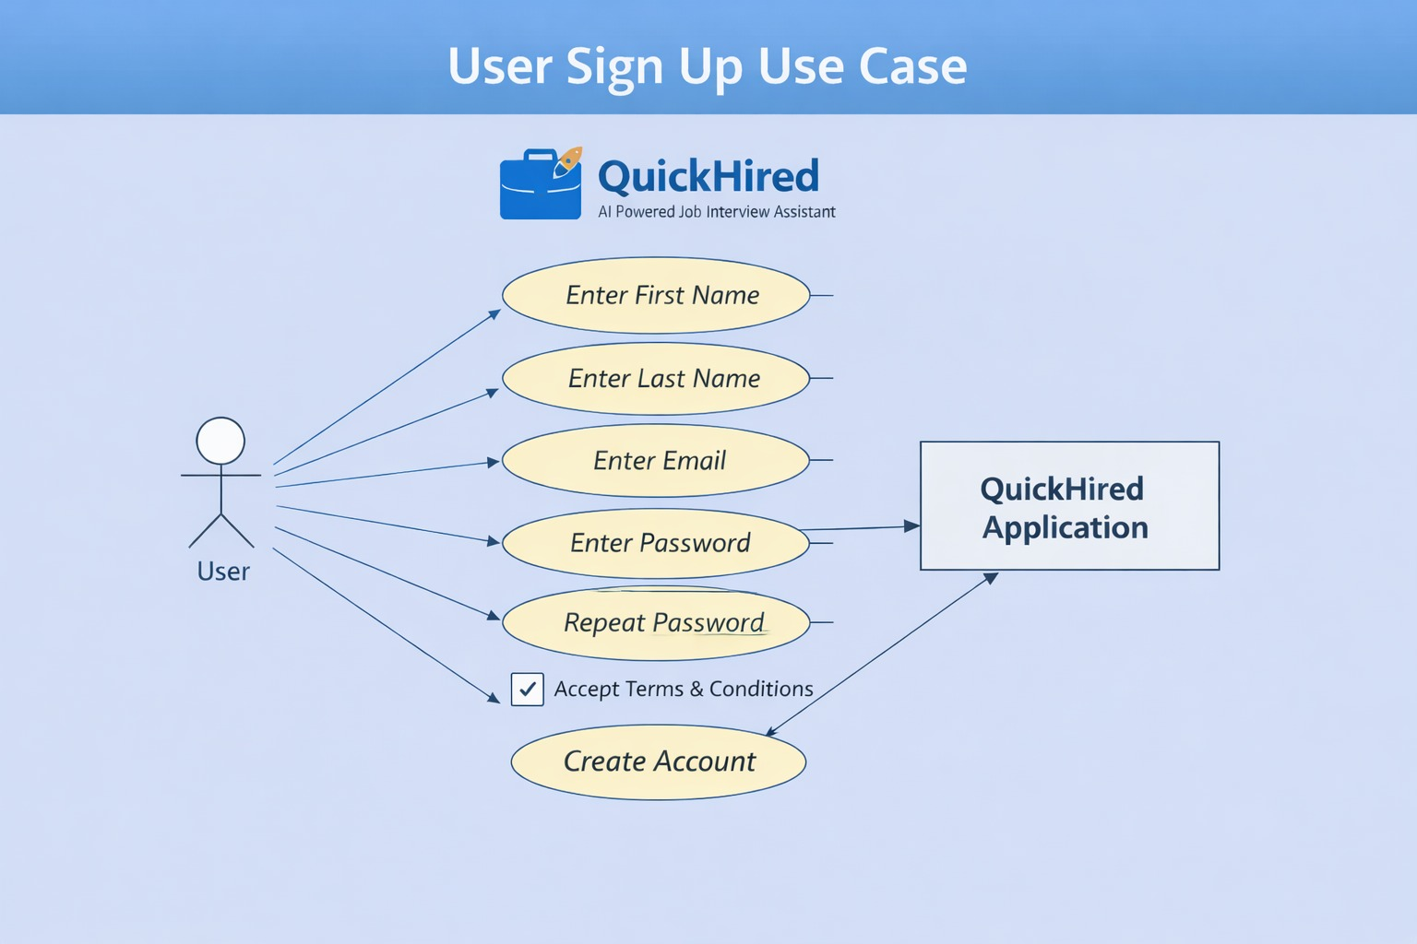
- UC-02: User Sign In
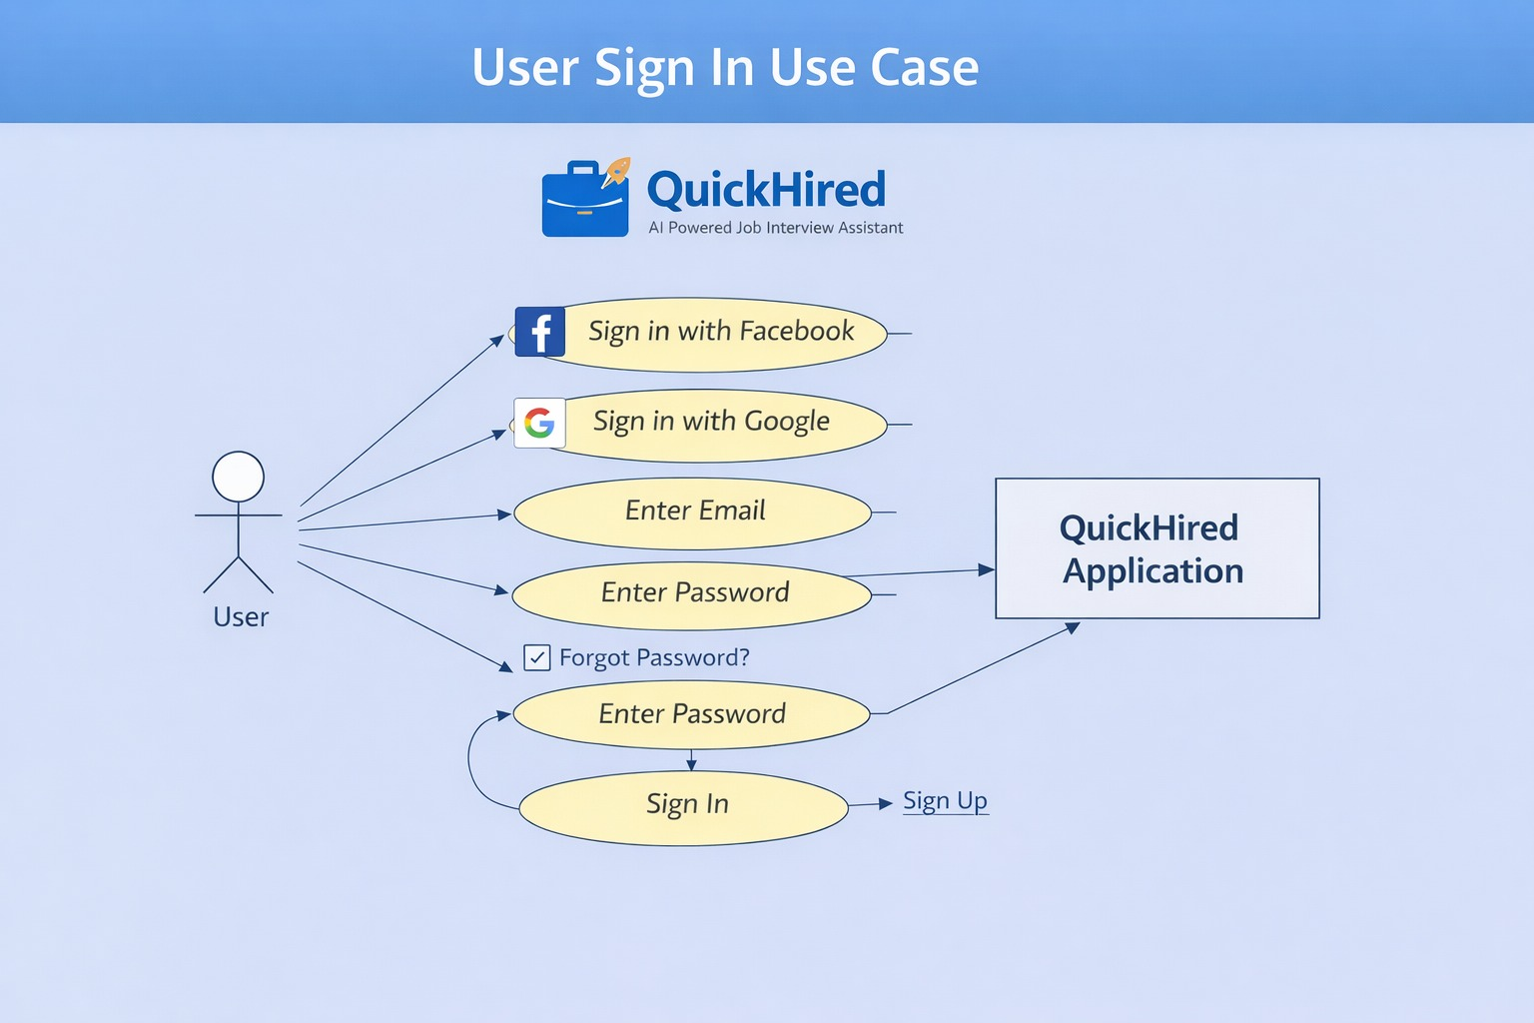
- UC-03: Email Verification
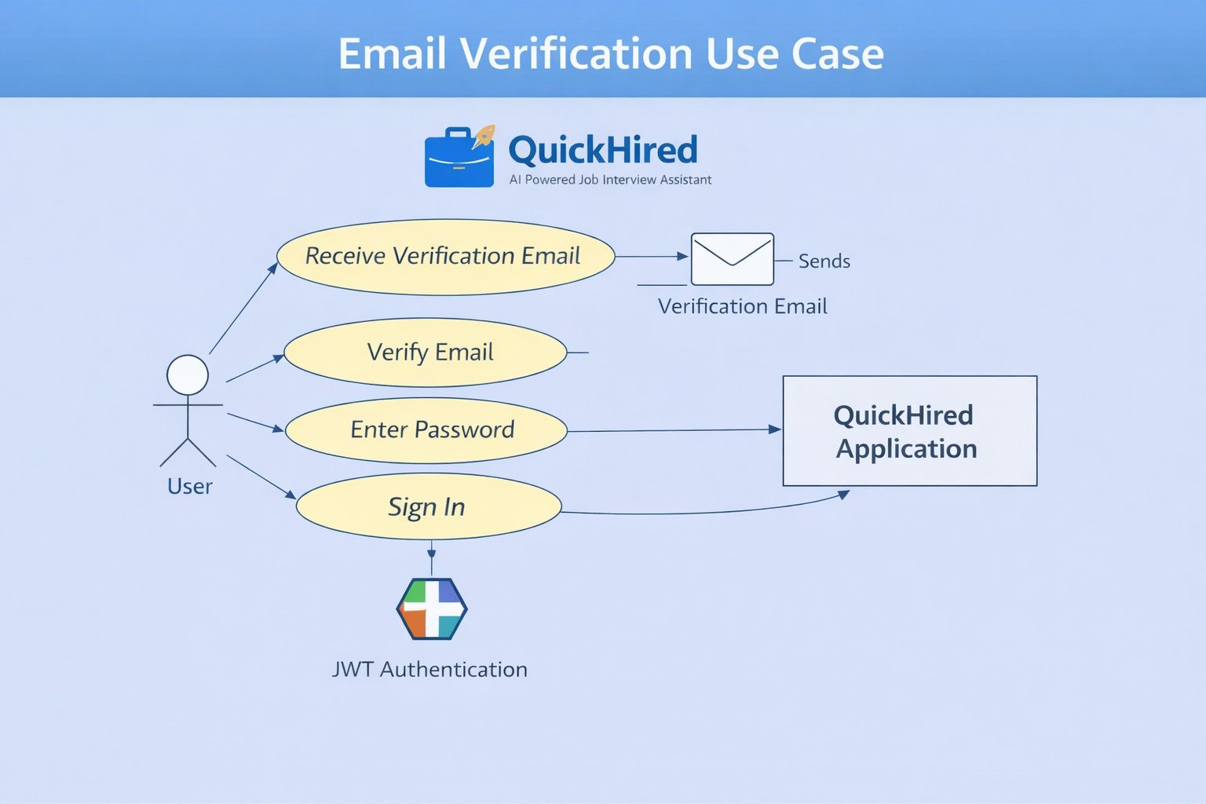
2. Storyboarding Technique
Storyboarding is also used because QuickHired has a graphical and step-by-step navigation flow. Each feature includes multiple screens, buttons, forms, and user interactions.

Storyboards help show:
- Screen designs
- Order of screens
- How users move from one step to another
- What buttons or actions are available
- How data flows from one page to the next
- Where Storyboarding is Useful in QuickHired
✔ Sign-Up Page Flow
✔ Login / Social Login Screens
✔ AI Interview Copilot setup screens (Resume, Job Details, Time Selection)
✔ Real-Time Interview Screen
✔ Mock Interview Screen
✔ Resume Builder (Left Form + Right Live Preview)
✔ AI Tools (Email Generator Preview Flow)
✔ Payment Plan Screens
✔ Reports Dashboard (Charts + Summaries)
These storyboards help the team visually understand:

User experience
- UI layout
- Sequence of events
- Navigation flow
Conclusion
Both techniques — Use Cases and Storyboarding — are used together to gather accurate requirements for the QuickHired application.
- Use Cases give detailed functional requirements.
- Storyboards show how the user will see and use the system.
- Together, these techniques help create a complete and clear requirement specification

2.3 Functional Requirements

This section describes all functional requirements of the QuickHired system. Functional requirements explain what the system must do. These requirements are organized by major system features to keep everything clear and easy to understand.

- Feature 1: User Registration & Authentication

FR-1: User Account Creation
- The system shall allow the user to register using first name, last name, email, password, and confirm password.
- The system shall validate that both passwords match.

FR-2: Terms & Conditions
- The system shall require the user to accept Terms & Conditions before successful registration.

FR-3: Email Verification
- The system shall send a verification email with a unique verification code.
- The system shall allow the user to enter the verification code to activate their account.
- The system shall verify the code and mark the user as “Verified”.

FR-4: User Login
- The system shall allow login using email and password.
- The system shall support social login (Google, Facebook).

FR-5: Session Management

- The system shall automatically log out inactive users after 30 minutes.
- If a user is in an interview session, the system shall not log them out until the session ends.

- Feature 2: AI Interview Copilot (Real Interview)

FR-6: Resume Upload
- The system shall allow the user to upload a resume in supported formats.

FR-7: Job Information Input
- The system shall allow the user to enter job title, job description, company name, and company description.
FR-8: Interview Type & Time Selection
- The system shall allow users to select interview type.
- The system shall allow selecting the interview duration up to 30 minutes.
FR-9: Screen Sharing
- The system shall allow users to share their browser screen for real-time interview assistance.
FR-10: Real-Time Question Detection
- The system shall detect interview questions spoken on the user's screen.
FR-11: AI Answer Generation
- The system shall generate appropriate answers using AI for each detected question.
- The system shall display answers back to the user in real time.

FR-12: Stop Interview
- The system shall allow the user to manually stop the interview.
FR-13: Summary Generation
- The system shall automatically generate an interview summary after interview ends.
- The system shall email the summary to the user.
- The system shall save summary, transcript, and interview report in the backend.

- Feature 3: AI Mock Interview (Practice Mode)
FR-14: Mock Interview Setup
- The system shall allow resume upload, job info, interview type selection, and time selection.

FR-15: Fetch Practice Questions
- The system shall fetch mock questions using integrated Glassdoor-based data scraping.
- The system shall also generate new practice questions using AI.
FR-16: User Answer Input
- The system shall allow the user to answer questions manually.
FR-17: Confidence Meter
- The system shall show a confidence bar based on the user’s response performance.
FR-18: Next Question Navigation
- The system shall allow user to click “Next Question” to continue the mock.
FR-19: Mock Summary
- After mock interview ends, the system shall show a summary including:
- Improvements
- Weaknesses
- The system shall save the report in backend.

- Feature 4: Question Bank
FR-20: Question Listing
- The system shall display company-based and role-based interview questions.
FR-21: Filtering
The system shall allow users to filter questions by:
- Company
- Job role
- Difficulty (if available)
FR-22: AI Answer Generation
- The system shall generate answers for selected questions using AI.

- Feature 5: AI Resume Builder

FR-23: Resume Template Display
- The system shall show a pre-made resume template.
FR-25: Live Preview
- The system shall update the resume preview in real-time as the user enters data.
FR-26: AI Content Enhancement
- The system shall enhance selected fields (e.g., skills, summary, experience) using AI when requested.
FR-27: Resume Saving
- The system shall allow users to save multiple resumes.

- Feature 6: AI Tools (Emails & Letters)
FR-28: AI Cover Letter Generation
- The system shall allow input fields for cover letter generation.
- The system shall generate the full cover letter using AI.
FR-29: AI Thank You Email
- The system shall generate thank-you emails based on user input.
FR-30: AI Follow-Up Email
- The system shall generate professional follow-up emails through AI.
FR-31: AI Recruiter Outreach Email
- The system shall create recruiter outreach emails using AI.
FR-32: Live Template Preview
- The system shall show a live preview of all generated content.

- Feature 7: Interview Reports

FR-33: Reports Dashboard
- The system shall display all interview and mock reports.
FR-34: Filtering
The system shall allow filtering reports by:
- Date
- Interview type
- Performance level
FR-35: Charts & Progress Tracking
- The system shall show performance charts including confidence level, weaknesses, improvements, etc.

- Feature 8: Payment & Subscription Plans

FR-36: Plan Display
- The system shall display available plans: Free, Standard Monthly/Yearly, Pro Monthly/Yearly.
FR-37: Limit Enforcement
- The system shall restrict access when the user reaches the limit of the free plan.
- The system shall show a pop-up asking the user to upgrade.
FR-38: Stripe Payment Integration
- The system shall integrate Stripe for secure payment processing.
FR-39: Auto-Renewal
- The system shall automatically charge monthly or yearly payments using saved card details.
FR-40: Update Payment Method
- The system shall allow users to update their saved card details.

- Feature 9: Meeting Recording

FR-41: Audio Recording
- The system shall allow users to record audio meeting sessions.
FR-42: Audio + Screen Recording
- The system shall allow users to record screen-based meetings.
FR-43: Saved Recordings
The system shall save audio recordings and transcripts.

Non-Functional Requirements (NFRs)
For: QuickHired — AI Powered Job Interview Assistant
1. Reliability
QuickHired is designed to handle real-time interviews, live audio/video recording, AI question answering, and large data processing. System reliability is ensured through the following mechanisms:
1.1 Stable Architecture
Backend uses .NET Core 8.1 with N-tier architecture, ensuring separation of concerns and reducing failure points.
Angular 17 frontend ensures stable communication with backend through optimized API calls.
1.2 Error & Exception Handling
Serilog Logging is implemented to capture:
- API failures
- Frontend errors
- Interview session crashes
- User activity logs
Logs help quickly identify system issues and ensure continuous uptime.

1.3 Email & Verification Reliability
SendGrid ensures reliable email delivery for:
- Sign-up verification codes
- Interview summaries
- Payment receipts
- High email deliverability ensures smooth onboarding and notifications.
1.4 Database Reliability
SQL database with:
- Regular backups
- Transaction integrity
- Atomic updates during interviews, reports, and payment operations
2. Usability
QuickHired is designed for users who want easy, fast, and guided AI-powered interview preparation. The UI/UX is simple, modern, and user-friendly.
2.1 Simple Onboarding
- Clean login/signup flow
- Social logins available (Google / Facebook)
- Email verification is straightforward via code input page
2.2 Easy Navigation
- Dashboard divided into:
- AI Interview Copilot
- AI Mock Interview
- QuestionBank
- AI Resume Builder
- AI Tools (Cover Letter, Follow-up Email, Thank-you Email, Recruiter Email)
- Reports
- Payment & Membership

2.3 Real-time UI Updates
When user enters resume/job details, they see live previews (Resume Builder, AI Tools).
- Live indicators during interviews:
- Confidence level
- Time spent
- Questions answered
2.4 Error-Free Form Submission
Every form (resume, interview details, job description, payment) has:
- Validation
- Clear error messages
- Helpful prompts
2.5 Multi-device Compatibility
- Responsive design
- Works smoothly on desktop, tablet, and mobile browsers
3. Performance
3.1 Fast Response Time
API responses optimized using:
- DTOs
- AutoMapper
- Lightweight endpoints
3.2 Efficient Frontend
- Angular 17 with optimized build system
- Lazy loading modules where possible
- Reduces load time and improves boot speed
3.3 Real-Time Interview Processing
The system handles:
- Real-time screen sharing
- Live question detection
- AI-generated responses in milliseconds
- Backend supports streaming and asynchronous operations for maximum speed
3.4 Scalable Infrastructure
System can support thousands of users simultaneously:
- Distributed services
- Load-balanced APIs
- Efficient database indexing
3.5 Performance monitoring
- In .NET, performance monitoring is done by collecting important runtime information and sending it to a logging system like Serilog.
- Serilog records details about each request, including execution time, errors, and system resource usage.
- This logged data is then displayed on dashboards for real-time monitoring.
API Latency:
A middleware measures how long each API request takes. Serilog stores the response time, and the dashboard shows it as a latency graph.
CPU and Memory Usage:
The .NET runtime provides information about processor and memory consumption. Serilog enrichers capture this data and send it to the dashboard.
Throughput (Requests Per Second):
Every incoming request is logged. Dashboards use these logs to calculate how many requests the system processes per second.
Errors Per Second:
When exceptions occur, Serilog logs them automatically. Dashboards count these error logs and show how many errors happen over time.
In simple terms:
.NET measures performance data, Serilog logs it, and dashboards convert those logs into visual charts for monitoring.

4. Security
Security is one of the most crucial aspects of QuickHired because it stores personal information, resumes, job details, interview recordings, and payment data.
4.1 Authentication & Authorization
JWT Authentication implemented for secure login
Token includes:
- User identity
- Roles
- Expiry
- Auto logout after 30 minutes of inactivity
- Interview sessions are never interrupted by session timeout
4.2 Secure Payment System
Stripe integration ensures:
- Secure subscription management (monthly/yearly)
4.3 Protected Interview Content
- Recorded interviews (audio/video/screen share) are stored securely
- Only the user can access their recordings, summaries, and transcripts
- Access-controlled endpoints protect sensitive data

2.5 External Interface Requirements

This section defines all external interfaces that interact with the QuickHired system, including user interfaces, software integrations, hardware requirements, and communication protocols.
2.5.1 User Interface Requirements
QuickHired provides a modern, responsive, and user-friendly interface developed using Angular 17. The following UI requirements apply to all modules (AI Interview Copilot, AI Mock, QuestionBank, AI Resume Builder, AI Tools, Reports, Payment, Authentication, and Record Meeting):

1. Authentication UI
Sign-up interface must include:
- First Name
- Last Name
- Email
- Password
- Confirm Password
- Acceptance of Terms & Conditions
- Email verification screen to enter a 6-digit verification code.
- Login with Google and Facebook buttons must be displayed clearly.
2. Dashboard UI
After successful login, user lands on a clean dashboard showing:
- AI Interview Copilot
- AI Mock Interview
- QuestionBank
- AI Resume Builder
- AI Tools
- Reports
- Payment & Membership
- Profile
3. Interview Copilot UI
Form to upload resume, job title, job description, company name, company description.
- Dropdown for interview type.
- Time selection up to 30 minutes.
- Screen-share permission popup.
- Live Interview Screen showing:
- Confidence meter
- Timer
- Questions panel
- AI-generated answers panel
- Stop Interview button

4. AI Mock Interview UI
- Animated AI interviewer character on one side.
- Question navigation panel.
- Area for user to speak and answer.
- Confidence bar displayed during responses.
Summary modal showing:
- Improvements
- Weaknesses
5. QuestionBank UI
Filters for:
- Company
- Job Role
- Category
- List of frequently asked questions.
- Answer panel powered by AI.
6. AI Resume Builder UI
Two-panel layout:
- Left: Form fields (Experience, Skills, Education, Projects, Personal Info)
- Right: Live Resume Preview
- Button: “Improve with AI”
7. AI Tools UI
- Template preview on right.
Tabs for:
- Cover Letter
- Follow-Up Email
- Thank You Email
- Recruiter Email
- Auto-filled AI content displayed instantly.

8. Reports UI
- Table listing all mock + live interview reports.
- Charts showing strengths, weaknesses, and progress.
- Transcript and summary viewer.
9. Payment UI
Page displaying:
- Free plan
- Standard (Monthly/Yearly)
- Pro (Monthly/Yearly)
- Stripe payment modal.
- Card update forms.
10. Record Meeting UI
- Audio/Video recording controls.
- “Start Recording” and “Stop Recording” buttons.
- Recording list viewer.
2.5.2 Software Interface Requirements
QuickHired integrates with several external software and internal components.
1. Backend–Frontend Integration
- RESTful APIs built in .NET Core 8.1
- JSON-based request/response format
- Endpoints secured with JWT tokens
2. AI Integration
AI engine integrated for:
- Answer generation
- Resume enhancement
- Cover letter generation
- Interview summaries
- Uses asynchronous API communication for fast processing

3. Glassdoor Web Scraping Integration
Custom scraping service to fetch:
- Company interview questions
- Job-role-specific question sets
- Data stored in backend for QuestionBank and Mock Interview
4. Stripe Payment Integration
- Auto-renewal for monthly/yearly subscriptions
- Card update API
Webhooks for:
- Payment success
- Payment failure
- Subscription cancellation
5. SendGrid Email Service
Used for:
- Sign-up verification
- Interview summary emails
- Receipts
- Notifications
6. Logging System (Serilog)
Integrated with backend to log:
- Errors
- Warnings
- API usage
- Performance metrics
7. Database Interface
- SQL Server database
8. Screen Share Integration
- Real-time streaming of user’s tab/window to the interview engine

2.5.3 Hardware Interface Requirements
QuickHired is a cloud-based web application, so hardware requirements apply mainly to the client-side device and internet connection.
For End Users
- Laptop/Desktop (recommended)
- Microphone (for mock/live interviews)
- Webcam (optional, for user confidence detection)
- Updated browser (Chrome, Edge, Firefox)
- For Mobile Users
- Android or iOS smartphone
- Microphone access required
- Screen-share may be limited on some smartphones (browser restrictions)
- For Server/Hosting
- (If self-hosted)

Cloud server with:
- Multi-core CPU
- High-speed SSD
- Secure HTTPS support
2.5.4 Communications Interface Requirements
1. Network Protocols
- All communication uses HTTPS (TLS 1.2 or higher).
- API calls use REST over HTTP/HTTPS.
- AI engine communication through secure encrypted channels.
2. Real-Time Communication
- Live interviews and screen sharing use WebRTC for:
- Low-latency streaming
- Real-time question capture
- Browser-based audio/video sharing

3. Email Communication
- Emails are sent via SendGrid SMTP/HTTP API.
- Verification code emails must arrive within 5 seconds.
4. Payment Communication
Stripe Webhooks are used for:
- Subscription events
- Payment status updates
- All webhook communication is validated with Stripe signatures.
5. Client–Server Communication
Angular frontend communicates using:
- JSON-based API calls
- Bearer token authentication
- Session timeout rules:
- Auto logout after 30 minutes of inactivity
- Interview sessions are exempt from timeout
6. Data Storage Communication
Entity Framework Core handles communication between:
- Business Layer (BLL)
- Data Access Layer (DAL)
- Database (SQL Server)

2.6 SUMMARY
This chapter analyzed the overall structure and requirements of the QuickHired system. It identified different user classes and explained their interaction needs. Various requirement-gathering techniques were used to define accurate system expectations. Functional requirements described the core features including AI interviews, resume building, reporting, and user management. Non-functional requirements ensured reliability, usability, performance, and security across all modules. External interface requirements covered UI design, software integrations, hardware usage, and communication protocols. Overall, this chapter provides a clear foundation for QuickHired’s design and development.

Chapter 3
System Design

Chapter 3.

System Design

Introduction
System design serves as the core architectural blueprint of any software application. This chapter presents the complete system architecture of QuickHired – AI Powered Job Interview Assistant, including its major components, authentication mechanism (JWT), database structure, and overall operational workflow.
The primary objective of this design is to develop a scalable, secure, and modular architecture that efficiently manages user authentication, interview processing, and AI-driven interaction while ensuring reliability and performance.

Overall System Structure:
The QuickHired system is based on a client–server architecture. The system operates through three major layers:
- Presentation Layer (Frontend)
- Application Layer (Backend / API Layer)
- Data Layer (Database Layer)
Presentation Layer (Frontend)
The frontend is responsible for handling all user interactions. This layer provides the interface through which users interact with the system. The major functions of this layer include:
- User Sign Up
- Email Verification
- User Sign In
- Starting an Interview Session
- Dashboard Access
- Profile Management
The frontend communicates with the backend through RESTful APIs to send and receive data securely.

Application Layer (Backend)
The backend implements the core business logic of the system. It processes requests received from the frontend and interacts with the database accordingly. The key modules of this layer include:
- Authentication Module
- JWT Token Generation and Validation
- Email Verification Module
- Interview Processing Module
- AI Integration Module
- User Management Module
The backend provides secure API endpoints that are protected using JWT-based authentication to ensure authorized access only.
Data Layer (Database)
The database layer is responsible for storing and managing system data, including user information, interview records, and authentication-related details.
The major database tables include:
- Users Table
- Email Verification Tokens Table
- Interview Sessions Table
- JWT Blacklist Table (optional security enhancement)
User Registration (Sign Up) Flow
When a user registers, the following fields are required:
- First Name
- Last Name
- Email
- Password
- Repeat Password
- Terms & Conditions Checkbox
- Create Account Button

Process Flow

1. The user submits the registration form.
2. The backend performs validation checks, including:
- Email format validation
- Password strength validation
- Password match verification
3. The password is securely hashed before storage.
4. A new user record is created in the database with the status set to *unverified*.
5. The system sends a verification email to the registered email address.
Email Verification Process
Email verification is a critical component of system security.
Flow
1. The system generates a unique verification token.
2. A verification email containing a secure link is sent to the user.
3. The user clicks the verification link.
4. The backend validates the verification token.
- If the token is valid:
- The user status is updated to *verified*.
- If the token is invalid or expired:
- An error message is displayed.
User Sign In Process
After successful email verification, the user can sign in to the system.
Sign In Options
- Enter Email and Password
- Sign In with Google
- Sign In with Facebook
- Forgot Password Link
- Sign Up Link
Authentication Flow
1. The user enters their email and password.
2. The backend validates the credentials.
3. If the credentials are valid:
A JWT Access Token is generated.
4. The token is sent to the client in the response.
5. The client attaches the token to every protected API request.
JWT Authentication Mechanism
The system uses JSON Web Token (JWT) based stateless authentication.
JWT Components
- Header
- Payload (User ID, Role, Expiry Time)
- Signature
Working Mechanism
1. After successful login, a JWT is generated by the backend.
2. The token is stored on the client side.
3. The token is included in the Authorization header with each request to protected endpoints.
4. The backend verifies the token signature.
5. If the token is valid, access to the requested resource is granted.
Security Considerations
- Implementation of JWT token expiry to enhance security
- Secure communication via HTTPS
- Mandatory email verification for all new users
- Input validation to prevent injection attacks and invalid data
- Rate limiting on login attempts to prevent brute-force attacks

System Workflow Summary
1. User Sign Up – User registers by providing required details.
2. Email Verification – User verifies their account through a confirmation email.
3. User Sign In – Verified users log in using email/password or social login.
4. JWT Generation – Upon successful login, a JWT token is generated for authentication.
5. Authorized Access to Dashboard – Users gain access to the application dashboard and features.
6. Interview Interaction – Users engage in AI-powered interview sessions or practice modules.

3.1 Design Considerations

Assumptions and Their Descriptions

Assumption 1: Users have a valid email address
Description: Every user must have a valid email address to complete the sign-up process, verify their account, and receive notifications such as interview session summaries, AI-generated reports, and password reset links.
Assumption 2: Users have access to a modern web browser
Description: The system assumes users access the application through modern web browsers (Chrome, Edge, Firefox) that support Angular 17 features, TypeScript, and screen-sharing functionalities required for AI Interview Copilot and AI Mock sessions.
Assumption 3: Users provide accurate resume information
Description: For real interviews and mock sessions, it is assumed that users provide correct and updated resume data. This ensures the AI Copilot can generate relevant interview questions, simulate realistic scenarios, and provide accurate feedback.

Assumption 4: Stable internet connection
Description: The application assumes users have a stable internet connection to handle real-time video/audio streaming, screen sharing, and AI-powered interview interactions without interruptions.
Assumption 5: System resources and API availability
Description: The system assumes that backend services (JWT authentication, email service via SendGrid, AI question generator) are running and accessible at all times for uninterrupted user operations, including sign-up, verification, and interview sessions.

3.2 Design Models
Design models system ke internal structure aur interactions ko visually represent karte hain. QuickHired project ke liye teen important models use kiye gaye hain:
- Class Diagram
- Interaction Diagram (Sequence Diagram)
- State Transition Diagram
Class Diagram
Description: A class diagram represents the static structure of the system. It depicts the system’s main classes, their attributes, methods, and the relationships among them. This helps in understanding how data is organized and how different modules interact with each other.

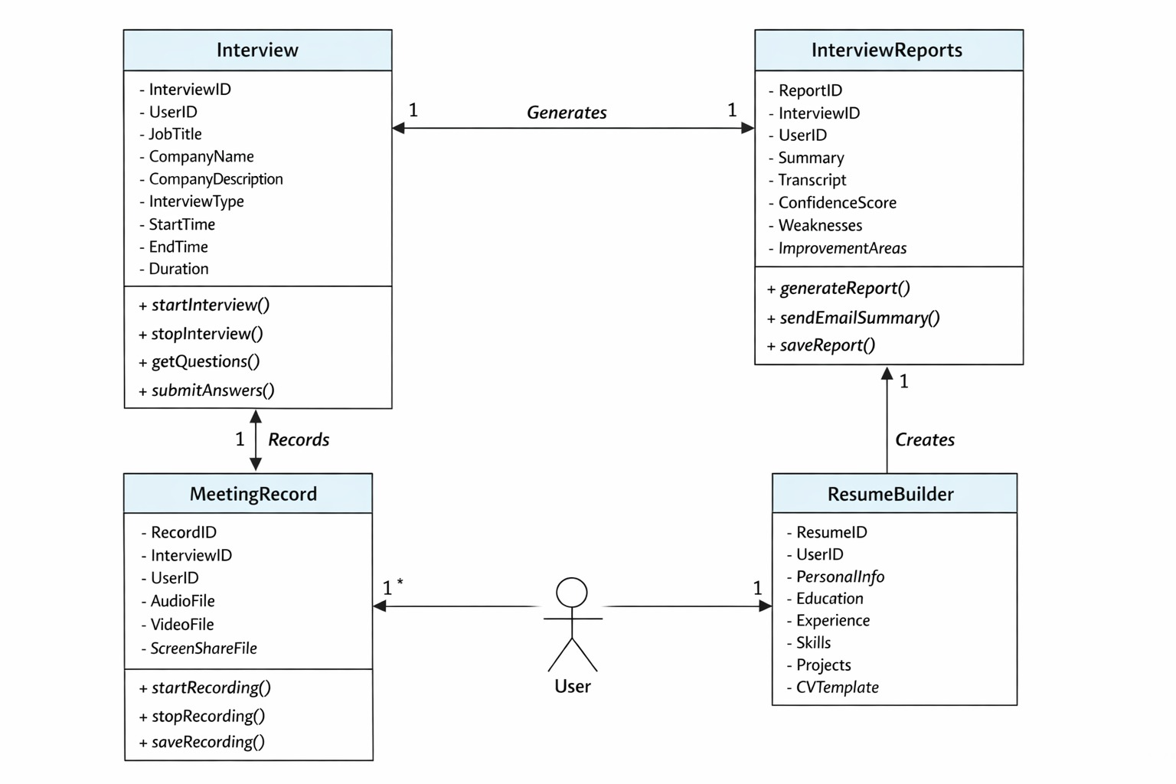
Sequence Flow for User Sign Up & Email Verification
Actors: User, Frontend (Angular), Backend (.NET Core), Email Service (SendGrid), Database
Steps:
- User fills the sign-up form (First Name, Last Name, Email, Password, Terms Checkbox)
- Frontend sends the data to Backend API
- Backend validates the form (Email format, Password strength, Password match)
- Backend hashes password and creates user record (Status: Unverified) in Database
- Backend generates email verification token
- Backend sends verification email via SendGrid
- User clicks verification link in email
- Backend validates the token and updates user status to Verified
- User can now sign in successfully

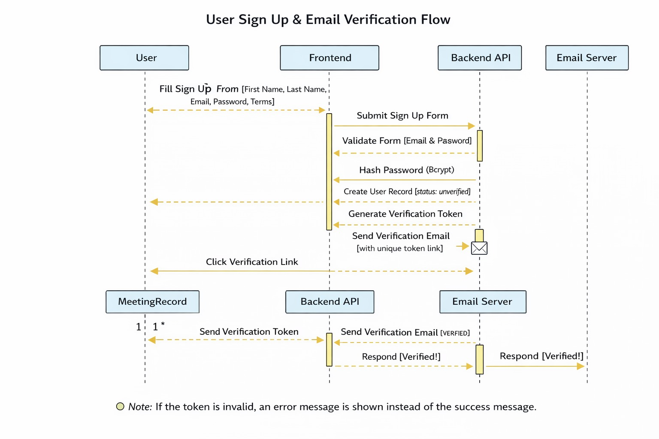

3.3 Architectural Design

Components for QuickHired Project:
1.User Interface (Frontend - Angular 17)
- Handles user interactions: Sign Up, Sign In, Dashboard, Interview Copilot, AI Mock, Resume Builder, Reports
- Communicates with Backend via REST API
2.Backend (API Layer - .NET Core 8.1)
- Authentication Module – JWT Token Generation, Validation
- User Management Module – CRUD operations for Users, Profiles
- Interview Module – Start/Stop Interviews, Question Handling
- AI Integration Module – AI Interview Copilot, Question Generation, Answers Suggestion
- Email Service Module – SendGrid Email for Verification, Reports
3.Database Layer
- Users Table – stores user credentials & profile
- Interview Sessions – stores session details, interview type, time
- Reports – stores transcripts, summaries, confidence scores
- JWT Blacklist / Tokens – optional security enhancement
4.External Services
- SendGrid – Email Sending Service
- Glassdoor Scraping – Fetch questions for AI Mock / Practice

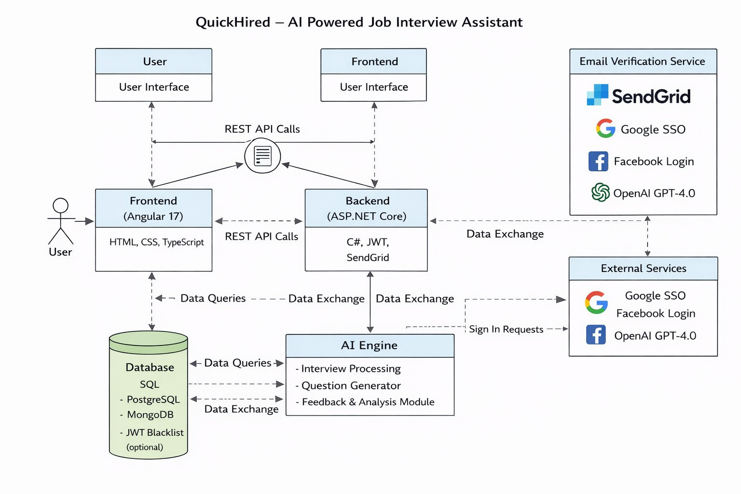3.4 Data Design

1. Users Table
- Stores user credentials and profile details.
- Fields: UserID, FirstName, LastName, Email, PasswordHash, Status (Verified/Unverified), CreatedAt, UpdatedAt
2. Email Verification Tokens Table
- Stores unique tokens for email verification.
- Fields: TokenID, UserID, Token, ExpiryDate
3. Interview Sessions Table
- Stores all user interviews (real or demo).
- Fields: SessionID, UserID, InterviewType (Real/Demo), JobTitle, CompanyName, JobDescription, StartTime, EndTime, Duration, Status
4. Interview Reports Table
- Stores generated summaries, confidence scores, and AI feedback.
- Fields: ReportID, SessionID, UserID, SummaryText, WeaknessAreas, ImprovementAreas, GeneratedAt
5. Meeting Records Table
- Stores recorded audio/video of interviews or practice sessions.
- Fields: RecordID, SessionID, UserID, FilePath, FileType, Duration, CreatedAt
6. Resume Builder Table
- Stores user resumes and related details for AI-assisted building.
- Fields: ResumeID, UserID, SectionsData (JSON), CreatedAt, UpdatedAt
7. JWT Blacklist Table (Optional)
- Stores invalidated JWT tokens for security enhancement.
- Fields: TokenID, Token, InvalidatedAt
Data Relationships:
- User → Interview Sessions: One-to-Many
- Interview Session → Interview Reports: One-to-One
- Interview Session → Meeting Records: One-to-Many
- User → Resume Builder: One-to-Many

3.5 Design Decisions

The following key design decisions were made for QuickHired to ensure scalability, security, and optimal user experience:
1. Frontend Framework – Angular 17
Angular was chosen because it provides a component-based architecture, efficiently handling user interactions (Sign Up, Sign In, Dashboard, Interview Copilot, AI Mock, Resume Builder).
- TypeScript is used for *type safety* and better maintainability.

2. Backend Framework – .NET Core 8.1

- .NET Core was selected for building cross-platform, high-performance, and scalable APIs*.
- Business logic, authentication (JWT), AI integration, email services, and interview session management are implemented on the backend.
3. Authentication Mechanism – JWT (JSON Web Tokens)
- JWT is used for stateless authentication.
- It ensures that protected API endpoints remain secure while maintaining efficient client-server communication.
4. Email Service – SendGrid
- SendGrid is used for verification emails and report notifications.
- It provides *reliable and scalable email delivery.
5. Database Design
- A relational database architecture was adopted (Users, InterviewSessions, Reports, MeetingRecords, ResumeBuilder).
- Relationships are defined to maintain referential integrity and data consistency.
6. AI Integration
- AI modules generate real interview responses and demo/mock interview questions.
- This ensures that interviews are interactive and AI-assisted.
7. Security Measures
- Password hashing, JWT expiry, HTTPS communication, input validation, and rate limiting are implemented.
- Mandatory email verification prevents unauthorized access.
8. Session Management
- User activity is monitored; after 30 minutes of inactivity, automatic logout is triggered.
- However, during active interviews or recordings, the session remains active until completion.

9. External Services Integration
- Glassdoor scraping is used to fetch interview questions, ensuring that the AI Mock feature provides real-world interview scenarios.
10. Modularity and Scalability
- The system follows a modular design (Frontend, Backend, Database, AI modules) to allow easy future enhancements and integration of new features.

3.6 Summary
QuickHired is designed as a scalable, secure, and modular AI-powered job interview assistant. The system uses a client-server architecture with Angular 17 on the frontend and .NET Core 8.1 on the backend. User authentication is secured using JWT, and email verification ensures account validity. The database is structured to handle users, interview sessions, AI-generated reports, meeting records, and resumes efficiently. AI integration enables real-time and mock interview simulations, while security measures like password hashing, HTTPS, and input validation protect user data. Overall, the design ensures smooth interaction between system components, secure data management, and an interactive experience for users.

Chapter 4
Implementation

Chapter 4:

Implementation

Introduction
The implementation phase of QuickHired – AI Powered Job Interview Assistant focuses on turning the system design into a fully functional, interactive application. This chapter explains how the system’s components, modules, and features are developed using Angular 17 for the frontend and .NET Core 8.1 for the backend.
During implementation, the designed system architecture, authentication mechanism (JWT), AI modules, database structure, and user interface workflows are realized. Special attention is given to user authentication, real and mock interview sessions, resume building, and report generation , ensuring a smooth and engaging experience for users.
This chapter also covers coding practices, API development, frontend-backend integration, and implementation of security measures such as password hashing, HTTPS, and input validation, all aligned with the project’s modular and scalable architecture.

4.1 Algorithm
QuickHired – AI Powered Job Interview Assistant
Input:
User interaction from the application UI (Signup, Login, interview details, resume, interview answers).
Output:
Completed interview session, transcript, summary & feedback report; plus user dashboards and additional AI tools outputs.
Algorithm Steps
1.User Accesses Website
- User navigates to the homepage.
- If already registered → Sign In page is shown.
- If not registered → Sign Up page with fields (First Name, Last Name, Email, Password, Terms).

2.User Registration
- User enters required sign‑up details.
- Backend validates fields (email format, password match & strength).
- If validation is successful:
- Password is hashed and user record is stored with status “unverified”.
- Verification email with unique token is sent.
3.Email Verification
- User clicks the verification link from the email.
- Backend checks the token validity.
- If valid → User status updated to “verified”.
- If invalid → Error returned with prompt to resend email.
4.User Sign In
- User can sign in via:
- Email & Password
- Google
- Facebook
- Backend checks credentials against database.
- If valid → Generate JWT token and return to client.

5.User Dashboard
- After login, user sees the main dashboard.
Options include:
- Start AI Interview Copilot
- Start AI Mock Interview
- Open Resume Builder
- View Interview Reports
- Use AI Tools (Cover Letter, Emails)
- JWT token is included in each protected API request for authorization.
- Start AI Interview Copilot
- User uploads resume and enters job title, company details, interview type, and session duration.
- Backend sets session status = Active → generates unique SessionID.
- User clicks Start Interview → Browser prompts screen share.
- System captures questions in real time and sends them through AI module.
- AI suggests answers based on interview responses and context.
- Backend captures audio/video/screen share recording.
6. Stop Interview
- User clicks Stop Interview.
- Interview session is closed.
- End time is recorded in database.
7.Generate Transcript & Summary
- Backend compiles all stored questions & responses.
- AI module runs on the transcript to create a summary report, highlighting:
- Strengths
- Weaknesses
- Confidence score
- Improvement areas
8.Store Report & Send Email
- Report data is saved in InterviewReports table.
- Summary is emailed to user with key metrics.
9. User Views Reports
- User can view saved interviews, transcripts, charts and progress dashboard.
10. Resume Builder & AI Tools
- User accesses Resume Builder to create/resume templates.
- Sections data stored in database (JSON/structured).
- AI Tools generate Cover Letters, Follow‑up Emails, Thank You Emails.
- User preview and save results.
11. Limit & Billing Check
- Application checks free plan limits.
- If user exceeds limits → Prompt to upgrade subscription.
- Payment managed via Stripe and membership records updated.

12.Repeat & Continue Interaction
- User can start new interview sessions, generate detailed reports, manage resumes, and view analytics any time after login.

4.2 External APIs/SDKs
Details of APIs used in the project (QuickHired)
1. Name of API and Version: Stripe API (v1)
Description: Online payment processing API for subscription-based systems.
Purpose of Usage: Manage Standard and Pro plans, recurring billing, payment processing, and webhook handling.
Endpoint / Class Used:
- PaymentController
- CreateCheckoutSession()
- StripeCustomerService
- /api/payment/webhook
2. Name of API and Version: SendGrid API (v3)
Description: Cloud-based email delivery service.
Purpose of Usage: Email verification, interview summary emails, payment confirmations, and system notifications.
Endpoint / Class Used:
- EmailService
- SendEmailAsync()
- Dynamic Email Templates
3. Name of API and Version: OpenAI API (Latest Version)
Description: AI-based natural language processing and content generation API.
Purpose of Usage:
- Generate real-time answers in AI Interview Copilot
- Generate mock interview questions
- Enhance resumes
- Generate cover letters and professional emails
Endpoint / Class Used:
- AIService
- GenerateInterviewResponse()
- GenerateMockQuestions()
- EnhanceResume()

4. Name of API and Version: Glassdoor Data Integration
Description: External interview question dataset source (used via scraping/data integration).
Purpose of Usage: Provide company-specific interview questions for AI Mock and QuestionBank features.
Endpoint / Class Used:
- QuestionService
- FetchCompanyQuestions()
- Background Data Fetch Job

5. Name of API and Version: JWT Authentication (ASP.NET Core)
Description: Token-based authentication and authorization mechanism.
Purpose of Usage: Secure login, protected APIs, role-based access control.
Endpoint / Class Used:
- AuthController
- GenerateJwtToken()
- JwtBearerOptions configuration

6. Name of API and Version: Serilog (Latest Stable Version)
Description: Structured logging framework for .NET applications.
Purpose of Usage: Exception handling, system logging, crash monitoring, and debugging.
Class Used:
- ILogger<>
- Program.cs logging configuration

7. Name of API and Version: AutoMapper (Latest Stable Version)
Description: Object-to-object mapping library for .NET.
Purpose of Usage: Map Entities to DTOs and DTOs to Entities in N-Tier architecture.
Class Used:
- MappingProfile.cs
- CreateMap<>()

4.3 Code Repository
In order to manage version control, collaboration, and structured development for QuickHired, Git will be used as the primary version control system. All project-related source code, documentation, database scripts, configuration files, and deployment resources will be maintained in a centralized Git repository.

Git Repository Link

The repository for the QuickHired project can be accessed using the following link:

[https://github.com/MAARTechDynamics/QuickHired_Frontend]

4.3.1 Metrics of the Git Repository

The following metrics will be monitored to ensure effective use of the repository:
1. Commits
- Number of commits per feature
- Commit frequency by team members
- Proper commit message structure (Conventional Commit format)
2. Branches
- Active feature branches
- Merged branches
- Release branches
- Hotfix branches

3. Pull Requests
- Number of PRs created
- PRs under review
- PRs merged
- Average review time
4. Issues
- Open bugs
- Closed bugs
- Feature requests
- Performance-related issues
5. Contributors
- List of contributors
- Commit statistics
- Code additions and deletions
- Feature ownership tracking
6. Code Reviews
- Number of reviews per PR
- Approval rate
- Rejection rate

4.4 Summary
Chapter 4 explained the complete implementation of QuickHired. It covered the core system algorithms for AI Interview Copilot, AI Mock, Resume Builder, and reporting modules. The integration of external APIs such as Stripe, SendGrid, AI services, and logging frameworks was also described. The chapter detailed the Git-based code repository structure and development workflow. Overall, the implementation ensures a secure, scalable, and well-structured system using Angular 17 and .NET Core 8.1.

Chapter 5
Introduction

Chapter No 5:

Testing and evaluation

Introduction
Software testing is a fundamental process carried out to ensure verification and validation of the QuickHired – AI Powered Job Interview Assistant system. The objective of testing is to confirm that the system functions according to the specified requirements, performs reliably under different conditions, and delivers accurate results, particularly in AI-driven interview generation, reporting, and payment handling.

5.1 Unit Testing (UT)
Unit Testing checks if individual parts of the QuickHired – AI Powered Job Interview Assistant work correctly. Each module, such as AI Interview Copilot, AI Mock, Resume Builder, and Payment System, is tested separately to ensure it functions without errors.
The objective is to confirm that each small component of the system performs exactly as expected in isolation.
The following modules are tested individually:
- User Registration & Email Verification
- Login & JWT Authentication
- AI Interview Copilot session creation
- AI Mock question generation
- Resume Builder live preview
- AI Tools (Cover Letter, Thank You Email, etc.)
- Payment & Subscription validation
- Report generation & transcript saving
This testing ensures that every independent feature works properly before being connected with other modules.

5.2 Functional Testing (FT)
Functional Testing verifies that each feature of QuickHired meets the project requirements and performs according to business logic.
This includes testing:
1. AI Interview Copilot
- Does it allow resume upload correctly?
- Does it generate AI answers during live interview?
- Does it create summary and transcript after interview ends?
2. AI Mock (Practice Mode)
- Does it generate relevant interview questions based on job title?
- Does it track confidence and session time?
- Does it show improvement and weakness analysis at the end?
3.QuestionBank
- Does it show company-specific interview questions?
- Does it generate AI-based answers for practice?
4. AI Resume Builder
- Does it update resume preview live?
- Does the “Enhance with AI” option improve content properly?
- Can multiple resumes be saved successfully?
5.Payment & Membership System
- Does the free limit stop user after usage limit?
- Does Stripe activate subscription correctly?
- Does recurring payment work properly?
This testing ensures that each feature works exactly as defined in the project requirements.

5.3 Integration Testing (IT)
Integration Testing checks how well different modules of QuickHired work together as one complete system.
It involves testing the interaction between:

1. AI Interview Copilot and Reports Module
To ensure interview transcript, summary, and performance data are saved correctly and displayed in Reports section.
2. AI Mock and AI Engine
To verify that questions generated from backend and AI are properly displayed in frontend.
3. Payment System and Feature Access Control
To ensure that upgrading a plan unlocks premium features instantly.
To verify that expired subscriptions restrict access automatically.
4. Database and User Interface
To confirm that resume data, interview reports, and membership details are correctly stored and displayed.
5. Email Service and User Actions
To ensure verification emails and interview summaries are sent properly after required actions.
This testing ensures that all modules of QuickHired work smoothly together as a single integrated AI-powered interview system.

5.4 Performance Testing (PT)
In order to assess the performance of the QuickHired application, performance testing is conducted to measure:
1. Response time
2. System stability under load
3. API throughput
4. Concurrent user handling
5. AI response latency
6. Database performance
7. Payment processing performance

Performance testing ensures that the system remains stable during high traffic, especially during:
1. Live AI Interview Copilot sessions
2. AI Mock interviews
3. Resume Builder AI generation
4. Stripe payment processing
5. Report generation
6. Meeting recording & transcript generation

Performance Testing Tool Used:
1. Browser DevTools (Frontend Performance)
2. SQL Profiler (Database Monitoring)
3. Serilog Logs (Error & Performance Logging)

5.5 Summary
The testing of QuickHired – AI Powered Job Interview Assistant confirms that all modules work correctly on their own and meet project requirements. Features like AI Interview Copilot, AI Mock, Resume Builder, and AI Tools function as expected. Integration between modules, database, reports, and payment system is seamless. Performance testing shows the application remains stable and responsive under heavy load. Overall, QuickHired is reliable, efficient, and ready for users to practice and manage interviews.

Chapter 6
Introduction

6.Introduction:
System conversion is the process of changing from one information system to another. This involves transferring data, processes, and operations from an old system to a new one.
6.1 Conversion Method
For the QuickHired – AI Powered Job Interview Assistant project, the selected system conversion method is: Phased Conversion:
Phased conversion is a method where the new system is implemented gradually in stages instead of replacing the old system all at once. This method is most suitable for our project because:
• The system is large and feature-rich
• It includes multiple AI integrations
• It involves payment processing (Stripe integration)
• It includes authentication and security mechanisms (JWT)
• It contains real-time processing features (Interview Copilot & Recording System)
Implementing everything at once would increase risk and system instability. Therefore, phased conversion ensures stability and controlled deployment.
Implementation of Phased Conversion in QuickHired
he system will be deployed in the following phases:
Phase 1 – Core System Deployment
• User Registration & Login (JWT Authentication)
• Email Verification (SendGrid Integration)
• AI Interview Copilot (Main Feature) • Stripe Payment Integration
• Basic Report & Summary
Generation This phase focuses on launching the primary functionality of the system.

Phase 2 – AI Mock Interview Module
• Practice/Demo Interview Mode
• AI-generated interview questions
• Glassdoor-based question integration
• Improvement & Weakness analysis
• Mock interview reports
This phase enhances user preparation capability.
Phase 3 – QuestionBank Module
• Company-based filtering
• Role-based question display
• Most commonly asked interview questions
• AI-generated answer suggestions
• Search and filtering system
Phase 4 – AI Resume Builder & AI Tools
• AI Resume Builder with live preview
• AI Cover Letter Generator
• AI Follow-Up Email Generator
• AI Thank You Email Generator
• AI Recruiter Outreach Email
This phase focuses on productivity tools.

Phase 5 – Advanced Reporting & Analytics
• Performance charts
• Confidence tracking
• Progress percentage
• Transcript history
• Meeting recording reports
Advantages of Phased Conversion for QuickHired
• Reduced implementation risk
• Early detection of system errors
• Controlled AI integration testing
• Reduced server crash probability
• Better scalability
• Improved user trust and system stability.
6.2 Deployment
Deployment refers to the process of building, configuring, and making the application operational in a production environment. It includes application build generation, database setup, configuration management, and verification of successful system launch.
6.2.1 Data Conversion
Data conversion ensures that existing system data is properly migrated to the deployed system without data loss or corruption. In QuickHired, data conversion involves the following steps:
Step 1 – Data Extraction
• Extract existing user data
• Extract interview records
• Extract transcripts and summaries
Data may be extracted from:
• Previous development database
• Backup files
• JSON exports
Step 2 – Data Cleaning
• Remove duplicate entries
• Validate email formats
• Validate foreign key relationships
• Remove corrupted records
• Standardize date/time formats
Step 3 – Data Validation
• Verify required fields (UserId, InterviewId, etc.)
• Validate password hashing format
• Ensure referential integrity
• Confirm Stripe subscription mapping
Step 4 – Data Backup Before loading into production:
• Create full database backup
• Store backup securely
• Verify restore capability
Step 5 – Data Loading
• Restore cleaned database into production SQL Server
• Run EF Core migrations (if required)
• Validate records inside production system

Step 6 – Post-Conversion Testing
• Login with migrated users
• Check interview history
• Verify report data
• Confirm transcript access
• Validate payment subscriptions
This ensures successful data migration.
6.2.2 Training
This section describes the user manual and training process for the system. Since QuickHired has multiple modules, training focuses on two main use cases:
1. AI Interview Copilot (Real Interview Mode)
2. AI Resume Builder
Use Case 1 – AI Interview Copilot (User Manual)
Step 1 – Registration
• User signs up
• Verifies email
• Logs into dashboard
Step 2 – Start Interview
• Click “Interview Copilot”
• Upload Resume
• Enter Job Title
• Enter Job Description
• Enter Company Name & Description
• Select Interview Type
• Select Session Duration (Max 60 minutes)

Step 3 – Start Interview
• Click “Start Interview”
• Share browser screen
• AI captures interview questions
• AI provides real-time answers
Step 4 – Stop Interview
• Click “Stop Interview”
• View generated summary
• Receive summary via email
• Access report in Reports section
Use Case 2 – AI Resume Builder (User Manual)
Step 1 – Open Resume Builder
• Navigate to AI Tools
• Select Resume Builder
Step 2 – Enter Resume Details
• Personal Information
• Education
• Experience
• Skills
• Certifications
Step 3 – AI Enhancement
• Click “Enhance with AI” for improvements

Step 4 – Preview & Save
• View live preview on right panel
• Save resume
• Download or edit later Training Method Training can be provided through:
• User documentation manual
• Video tutorials
• On-screen tooltips
• Demo practice mode
• FAQ section
This ensures users can efficiently use the QuickHired platform without difficulty.
6.3 Post Deployment Testing
Post Deployment Testing refers to the process of verifying that the software system has been successfully deployed and that all system components are functioning correctly after deployment and data conversion
. • The purpose of this phase is to ensure:
• The application is properly deployed
• Data conversion has been completed successfully
• All modules are functioning correctly
• No configuration errors exist
• System performance and security are stable
1. Application Availability Testing
• Verify that the frontend loads correctly in the browser
• Confirm that backend API endpoints are accessible
• Review Serilog logs for runtime errors
• Confirm database connectivity

- Authentication and Authorization Testing
• Test new user registration
• Verify email confirmation using SendGrid
• Test JWT-based login functionality
• Verify role-based access (Free, Standard, Pro plans)
• Test session timeout after 30 minutes of inactivity
• Ensure session does not expire during active interviews
- AI Interview Copilot Testing
• Upload resume functionality testing
• Submit job title, job description, company details
• Select interview duration (maximum 30 minutes)
• Test “Start Interview” functionality
• Verify browser screen sharing
• Confirm real-time AI answer generation
• Test “Stop Interview” functionality
• Verify summary generation
• Confirm email summary delivery
• Ensure transcript and report are stored in the database
- AI Mock Interview Testing
• Start demo/mock interview
• Verify AI-generated questions
• Validate Glassdoor-based question integration
• Test user answer input
• Confirm confidence tracking functionality
• Verify improvement and weakness report generation

- QuestionBank Testing
• Select company and role
• Test filtering system
• Verify question loading
• Confirm AI-generated answer suggestions
• Test search functionality
- AI Resume Builder & AI Tools Testing Resume Builder
• Enter resume details
• Verify live preview updates
• Test “Enhance with AI” feature
• Save and edit resume functionality
• Generate Cover Letter
• Generate Follow-Up Email
• Generate Thank You Email
• Generate Recruiter Email
• Verify dynamic preview updates
- Payment System Testing
• Verify free plan usage limits
• Test Standard monthly subscription
• Test Pro subscription
• Confirm successful Stripe payment transactions
• Test auto-renewal functionality
• Verify card update process
• Test payment failure scenarios

- Data Conversion Verification
• Confirm migrated users can log in
• Verify previous interview reports are accessible
• Check transcript availability
• Validate resume data integrity
• Confirm correct subscription mapping
- Performance and Load Testing
• Test multiple simultaneous users
• Monitor server performance during live interviews
• Check CPU and memory utilization
• Review application logs for performance issues
- Security Testing
• Verify unauthorized API access is blocked
• Validate JWT token authentication
• Test SQL injection prevention
• Confirm HTTPS configuration
• Verify CORS policies
6.4 Challenges
During the deployment and operationalization of the QuickHired – AI Powered Job Interview Assistant system, several technical and operational challenges were encountered. Below are the major challenges and their corresponding solutions.
  - AI Real-Time Processing Delay Challenge:
The AI Interview Copilot required real-time processing of interview questions and immediate response generation. Initially, response delays occurred due to API latency and server processing load.

Solution:
• Optimized backend API calls
• Implemented asynchronous programming in .NET Core
• Improved request handling using task-based operations
• Optimized AI prompt structure to reduce processing time
  - Screen Sharing Integration Issues Challenge:
Browser screen-sharing permissions and compatibility issues caused failures during the “Start Interview” process.
Solution:
• Implemented browser compatibility checks
• Added user permission validation before interview start
• Displayed proper error messages for denied permissions
• Tested across multiple browsers (Chrome, Edge)
  - JWT Authentication & Session Timeout Conflicts Challenge:
The system required automatic logout after 30 minutes of inactivity, but active interview sessions should not expire. This created session handling conflicts.
Solution:
• Implemented activity-based session tracking
• Disabled session timeout during active interview sessions
• Added middleware to monitor user activity
• Tested token refresh mechanisms
  - Stripe Payment Integration Complexity Challenge:
Integrating subscription-based payment plans (Free, Standard, Pro – Monthly & Yearly) with automatic renewal required accurate webhook handling.

Solution:
• Configured Stripe webhooks properly
• Implemented secure API key management
• Validated subscription status before feature access
• Tested payment success and failure scenarios
  - Email Delivery Issues (SendGrid Integration) Challenge:
Email verification and summary emails were occasionally delayed or marked as spam.
Solution:
• Verified domain authentication in SendGrid
• Configured proper sender authentication
• Implemented retry mechanism for failed email attempts
• Monitored email logs
  - Data Migration & Integrity Issues Challenge:
During database restoration and migration, foreign key conflicts and duplicate records were encountered.
Solution:
• Cleaned and validated data before migration
• Applied Entity Framework migrations carefully
• Implemented data validation scripts
• Performed backup before production restore
  - Performance Under Load Challenge:
Simultaneous users starting interviews caused increased server load and higher CPU utilization.

Solution:
• Optimized database queries
• Implemented efficient logging with Serilog
• Reduced unnecessary API calls
  - Security Concerns Challenge:
Since the system handles sensitive data (resumes, transcripts, payment information), ensuring high security was critical.
Solution:
• Implemented JWT-based authentication
• Secured APIs with role-based authorization
• Enabled HTTPS
• Applied input validation and SQL injection prevention
• Protected API keys using environment variables
  - AI Prompt Accuracy and Response Quality Challenge:
AI-generated answers sometimes lacked relevance to the specific job role.
Solution:
• Improved prompt engineering
• Added job title and job description context
• Implemented structured input formatting
• Performed continuous testing and refinement
6.5 Summary
The deployment process of the QuickHired – AI Powered Job Interview Assistant was comprehensive and structured. It involved building the application, configuring the database, setting up API and frontend connections, and making the application fully operational in a live environment.

Chapter 7
Introduction

7. Introduction
This chapter presents the conclusion of the project and provides an overall evaluation of the system. It assesses whether the objectives defined in Chapter 1 have been successfully achieved in the developed Final Year Design Project (FYDP).
7.1 Evaluation
This section evaluates the project by comparing the objectives defined in Chapter 1 with the actual implementation of the system. The table below shows whether each objective has been successfully achieved.
Objective Status Table
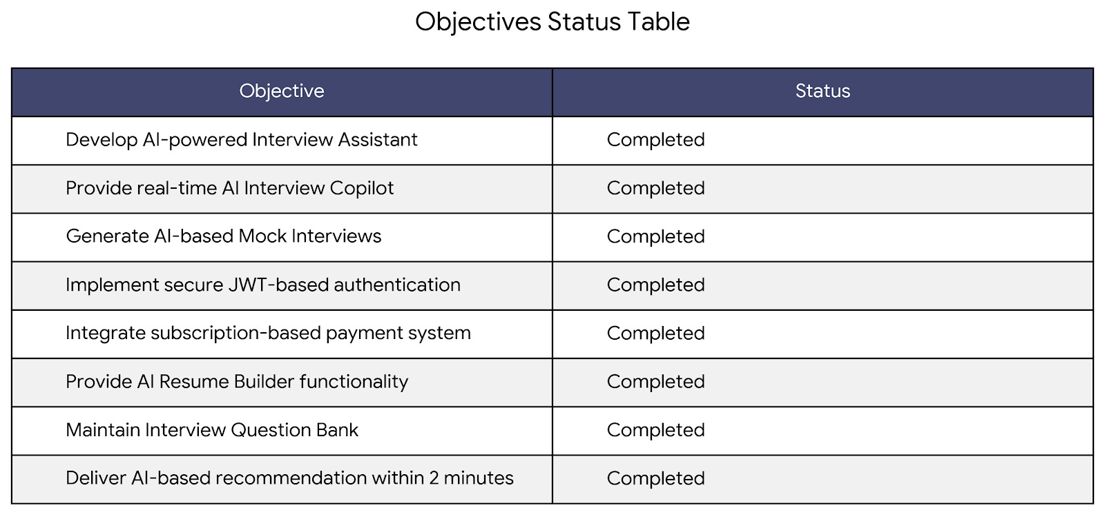

7.2 Traceability Matrix
The Traceability Matrix shows how each design, code, and test configuration item relates to a specific requirement from the Software Requirements Specification (SRS). This ensures that all requirements are properly implemented in the final product.
Requirement Traceability
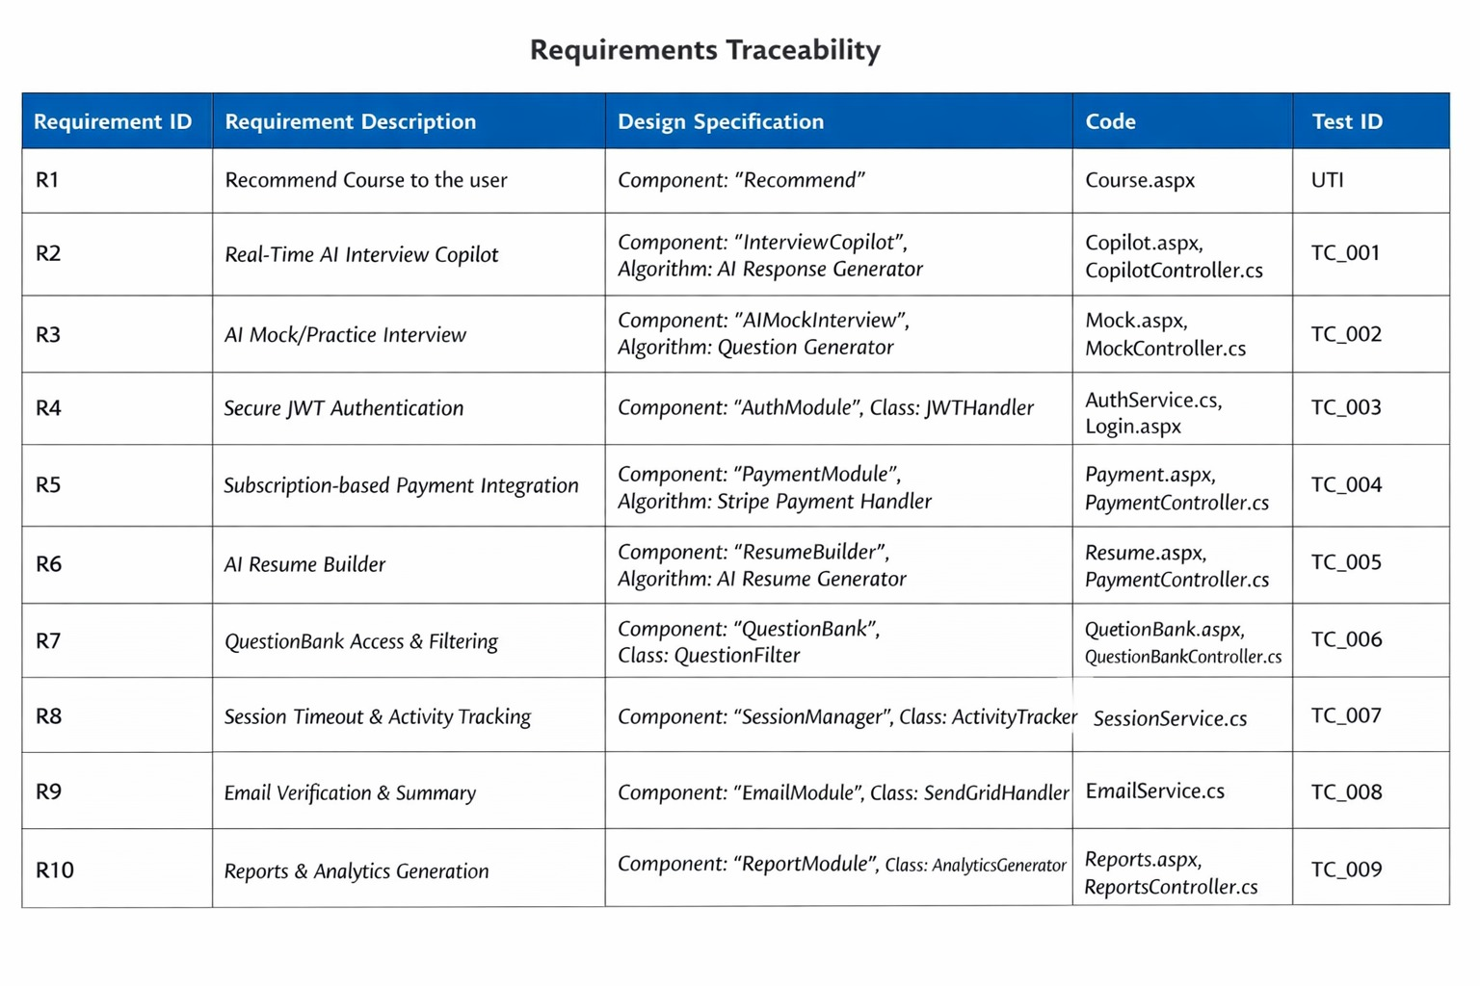

7.3 Conclusion
The QuickHired – AI Powered Job Interview Assistant project has successfully achieved the objectives defined at the beginning of the project. The system provides a comprehensive solution for job seekers, offering real-time AI interview assistance, mock interviews, AI-enhanced resume building, a question bank, and subscription-based services.
7.4 Future Work
In the future, the QuickHired – AI Powered Job Interview Assistant can be enhanced and expanded with additional features, optimizations, and improvements. The following suggestions are proposed for future work:
  - Multi-Language Support:
Adding multi-language capabilities to allow international users to access and use the system efficiently.
  - AI Personality Analysis:
Analyzing user tone, body language, and response patterns during interviews to provide detailed AI-generated feedback and improvement suggestions.
  - Advanced Analytics & Progress Tracking:
Implementing interactive dashboards and advanced analytics to monitor user performance trends over time.
  - Video Feedback & AI Coaching:
Providing personalized video feedback and AI coaching after interviews to help users improve weak areas.
5. Gamification Features:
Adding gamification elements such as badges, levels, and performance streaks to increase user engagement and motivation.
6.Scalability Improvements:
Implementing cloud-based infrastructure and load balancing to support large-scale user traffic efficiently.

7.Enhanced AI Question Generation:
Improving the AI question generator to create advanced, company-specific, and role-specific questions with real-time updates.
8. Collaboration & Group Mock Interviews:
Introducing group practice and peer review sessions to enable collaborative learning and more effective preparation.

Prototype



